
Country Report

Sharks and Rays Data Collection in Thailand

Tassapon KRAJANGDARA
Montri SUMONTHA
Suwantana TOSSAPORNPITAKKUL

Department of Fisheries, THAILAND

A report submitted to SEAFDEC on Sharks and Rays Data Collection in Southeast Asia Project
August, 2016
CONTENTS
No |  | Pages
1 | INTRODUCTION
1.1 | Objectives
1.2 | Data Collection at Landing Sites
1.2.1 | Selection of Study Sites
1.2.2 | Fishery Structure and Background of Study Sites
1.3 | Appointment of Enumerators
1.4 | Materials and Methods
1.4.1 | Sampling Methods
1.4.2 | Selection of Fishing Vessels and Sampling Activities
1.4.3 | Classification
2 | RESULT
2.1 | Songkhla
2.1.1 | Landing Samples
2.1.2 | Fishing Ground and Catch Composition by Gear Type
2.1.3 | Sharks and Rays Composition
2.1.4 | Number of Sample
2.1.5 | Weight of Sharks and Rays by Species
2.1.6 | Size Range of Sharks and Rays
2.1.7 | Catch Per Unit Effort
2.1.8 | Usage and Marketing
2.2 | Ranong
2.2.1 | Landing Samples
2.2.2 | Fishing Ground and Catch Composition by Gear Type
2.2.3 | Sharks and Rays Composition
2.2.4 | Number of Sample
2.2.5 | Weight of Sharks and Rays by Species
2.2.6 | Size Range of Sharks and Rays
2.2.7 | Catch Per Unit Effort
2.2.8 | Usage and Marketing
3.0 | CONCLUSION
4.0 | Out come and Out Put
5.0 | Future Activity
 | References
 | Appendix

List of Tables
No | Contents | Page
Table 1 | Number of Licensed Trawlers at Songkhla and Ranong Province
Table 2 | Number of Landings Sampled During the Study at Songkhla Fishing Port
Table 3 | Weight of Sharks and Rays (in kg) Caught by Trawls at Songkhla Fishing Port
Table 4 | Catch Composition of Sharks, Rays, Commercial and Low-value Species (LVS) by Month from 115 Trawler Landings at Songkhla Fishing Port
Table 5 | Number of Sample of Sharks and Rays by Species at Songkhla Fishing Port
Table 6 | Weight of Sharks and Rays (in Kg) by Species from 115 Trawler Landings at Songkhla Fishing Port
Table 7 | Size Range (cm) of Sharks, Rhinobatiformes (Total Length) and Rays (Disc Length) at Songkhla Fishing Port
Table 8A | Days at Operation by Trawls Sampled during August 2015-July 2016 at Songkhla Fishing Port
Table 8B | Numbers of Haul by Trawls Sampled during August 2015-July 2016 at Songkhla Fishing Port
Table 9A | CPUE of Rays Captured by Otter-board Trawl during August 2015-July 2016 at Songkhla Fishing Port
Table 9B | CPUE of Rays Captured by Paired Trawl during August 2015-July 2016 at Songkhla Fishing Port
Table 9C | CPUE of Sharks Captured by Otter-board Trawl during August 2015-July 2016 at Songkhla Fishing Port
Table 9D | CPUE of Sharks Captured by Paired Trawl during August 2015-July 2016 at Songkhla Fishing Port
Table 10A | CPUE of Rays (Individuals) Captured by Otter-board Trawl during August 2015-July 2016 at Songkhla Fishing Port
Table 10B | CPUE of Rays (Individuals) Captured by Paired Trawl during August 2015-July 2016 at Songkhla Fishing Port
Table 10C | CPUE of Sharks (Individuals) Captured by Otter-board Trawl during August 2015-July 2016 at Songkhla Fishing Port
Table 10D | CPUE of Sharks (Individuals) Captured by Paired Trawl during August 2015-July 2016 at Songkhla Fishing Port
Table 11 | Price of Sharks and Rays by Species at Songkhla Landing Site during 2015-2016
Table 12 | Number of Landings Sampled During the Study at Ranong Fishing Port
Table 13 | Weight of Sharks and Rays (in kg) Caught by Trawls at Ranong Fishing Port
Table 14 | Catch Composition of Sharks, Rays, Commercial and Low-value Species (LVS) by Month from 70 Trawler Landings at Ranong Fishing Port
Table 15 | Number of Sample of Sharks and Rays by Species at Ranong Fishing Port
Table 16 | Weight of Sharks and Rays (in Kg) by Species from 70 Trawler Landings at Ranong Fishing Port
Table 17 | Size Range (cm) of Sharks, Rhinobatiformes (Total Length) and Rays (Disc Length) at Ranong Fishing Port
Table 18A | Days at Operation by Trawls Sampled during September 2015- August 2016 at Ranong Fishing Port
Table 18B | Numbers of Haul by Trawls Sampled during September 2015- August 2016 at Ranong Fishing Port
Table 19A | CPUE of Rays Captured by Otter-board Trawl during September 2015- August 2016 at Ranong Fishing Port
Table 19B | CPUE of Rays Captured by Paired Trawl during September 2015- August 2016 at Ranong Fishing Port
Table 19C | CPUE of Sharks Captured by Otter-board Trawl during September 2015- August 2016 at Ranong Fishing Port
Table 19D | CPUE of Sharks Captured by Paired Trawl during September 2015- August 2016 at Ranong Fishing Port
Table 20A | CPUE of Rays (Individuals) Captured by Otter-board Trawl during September 2015- August 2016 at Ranong Fishing Port
Table 20B | CPUE of Rays (Individuals) Captured by Paired Trawl during September 2015- August 2016 at Ranong Fishing Port
Table 20C | CPUE of Sharks (Individuals) Captured by Otter-board Trawl during September 2015- August 2016 at Ranong Fishing Port
Table 20D | CPUE of Sharks (Individuals) Captured by Paired Trawl during September 2015- August 2016 at Ranong Fishing Port
Table 21 | Price of Sharks and Rays by Species at Ranong Landing Site during 2015-2016
Table 22 | Output and Outcome

- INTRODUCTION

The marine fishery production of Thailand was harvested from the Gulf of Thailand and the Andaman Sea. Most of the production (90%) was caught by commercial fishing gears and the rest was caught by small scale fishing gears. Trawl fishery landed about 70% of the total production in Thai Waters. But, there is no shark’s fishery in Thailand. Sharks and rays are caught by a number of fishing gears such as trawls, purse seines, long lines, gill nets and others, especially by the otter-board trawl. Generally, sharks and rays are not the target species but caught as by-catch or incidental catch by marine capture fisheries. There are no specific types of fishing gears to catch only for sharks and rays. Sharks and rays in the total catch were less than 0.5% of total marine fishery production. Moreover, shark and ray productions are fully utilised in Thailand. Species diversity of sharks and rays in Thai Waters and adjacent areas recorded 135 species comprising 64 sharks and 71 rays (including 1 skate), belonging to 19 families of sharks and 11 families of rays (Krajangdara, 2014).
The cartilaginous fishes or chondrichthyans in Thai Waters and adjacent areas are currently revised and updated in 2016 for supporting database system of NPOA-Sharks, Thailand. The new checklist of cartilaginous fishes was included the record of 162 species, composed of 76 sharks, 79 rays, 5 skates, and 2 chimaeras. These belong to 21 families of sharks, 14 rays, 2 skates, and 1 chimaeras. The high diversity of sharks was recorded from the Orders Carcharhiniformes, Orectolobiformes, Lamniformes and Squaliformes with 49, 10, 7 and 5 species, respectively. (In this checklist, Family Echinorhinidae is in Order Squaliformes. But Ebert et al. (2015) and Weigmann (2016) classified this family to new order, Echinorhiniformes). However, low diversity was record for the Orders Hexanchiformes and Squatiniformes with 2 species in each order. Species diversity in the Order Heterodontiformes was scanty and found only 1 species. As for batoids, high diversity was recorded for the Order Myliobatiformes with 54 species followed by Rhinobatiformes and Torpediniformes with 14 and 8 species, respectively. Only 5 species were recorded from the Order Rajiformes and 3 species from Pristiformes. The details of the cartilaginous fishes checklist are shown in Appendix I. Even though the stock status of chondrichthyans species in Thailand is still insuficient. With the new record of chondrichthyans species continuously discovered and expected to increase in the future. At present the deep water species are mostly unknown due to limited research activity. Most sharks and rays species landed in Thailand are mainly from the Families Carcharhinidae and Dasyatidae, however, it was very difficult to identify up to species level by untrained and inexperienced enumerators. Only well-trained staff will be better able to make the right and valid identification of species.

1.1 Objectives

The objectives of this project were:
- to enhance human resource development in elasmobranch taxonomy, and
- to improve landing data recording from generic ‘sharks’ and ‘rays’ to species level.

1.2 Data Collection at Landing Sites
1.2.1 Selection of Study Sites
The Southern Thailand is a major landing site for sharks and rays. The selected sampling sites in the Gulf of Thailand was Songkhla province (comprising 6 districts in namely Ranot, Sathing Phra, Singhanakhon, Muang Songkhla, Chana and Thepa) and in the Andaman Sea was Ranong province (comprising 3 districts in namely Muang Ranong, Kapoe and Suk Samran). Although, there were many type of fishing boats landed in sampling sites such as paired trawler, otter-board trawler, purse seiner, gillnetter and longliner, but the 1-year data collection on sharks and rays in Thailand were only recorded from paired trawler and otter-board trawler which are the main fishing gears for catching sharks and rays. The landing data were collected at 2 fishing ports of fish marketing organization of Songkhla and Ranong where located in Muang district of both sites. The location of landing sites are shown in Figure 1.
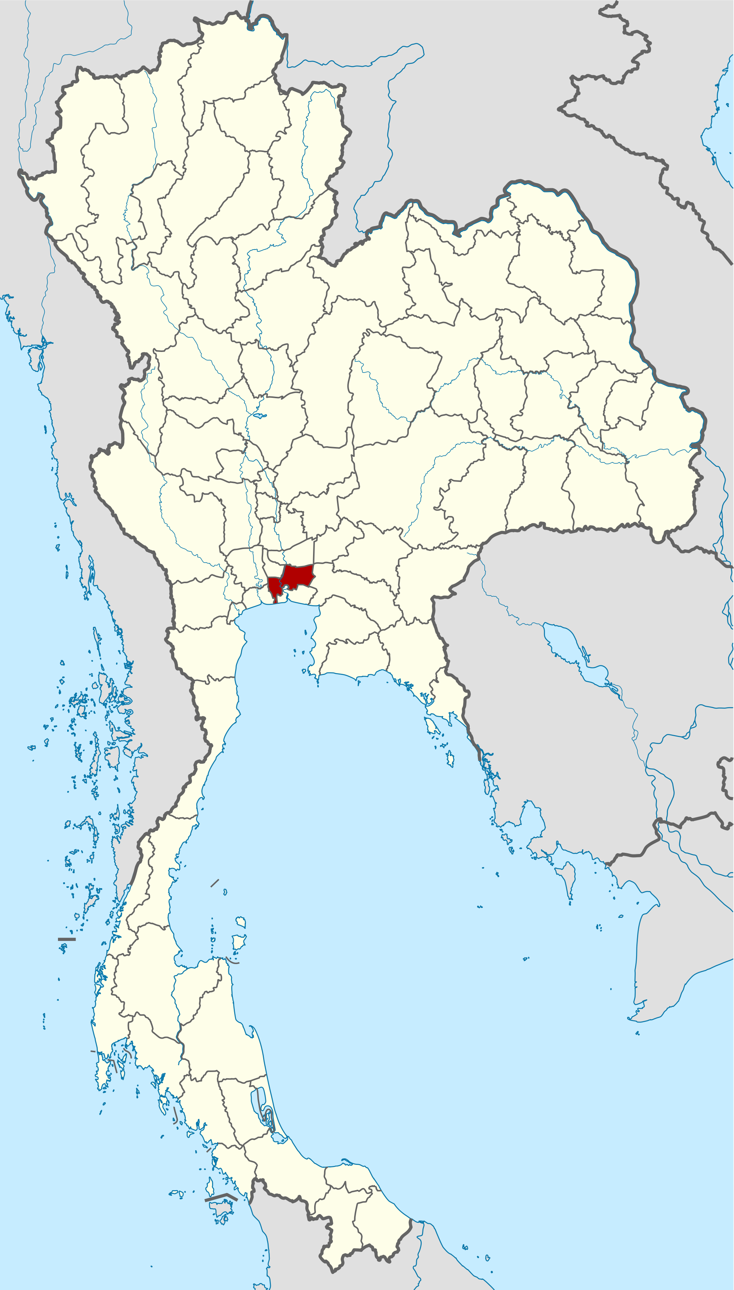
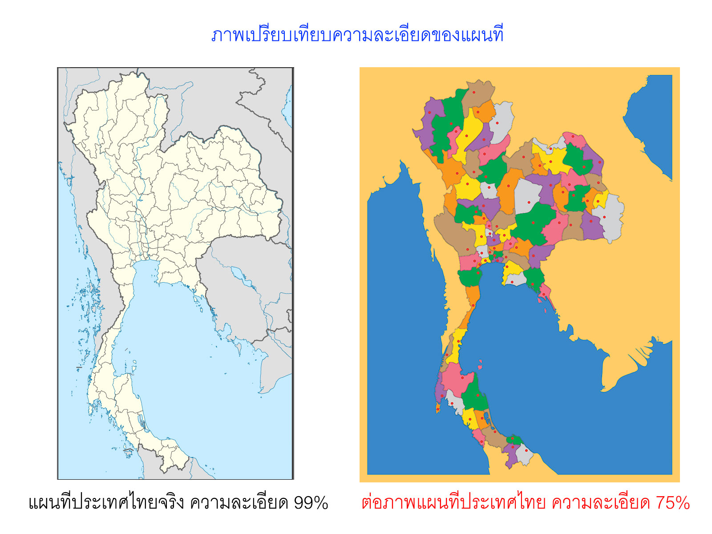
The Gulf of ThailandAndaman Sea
Songkhla Fishing Port
Ranong Fishing Port

Figure 1: Location of Study Sites in the Southern Thailand
1.2.2 Fishery Structure and Background of Study Sites
Songkhla Fish Marketing Organization or Songkhla Fishing Port is one of the major landing sites for sharks and rays in the east coast of Southern Thailand. The major gears were trawl nets (260) comprising 247 otter-board trawls and 13 paired trawls. All trawlers are normally operated by 4-6 crew members. All catches were landed from 0500-1100hr by trawlers operating more than 3 nautical miles from the coastline. Fishing operations normally were operated between 4 to 30 days per trip. While Ranong Fish Marketing Organization or Ranong Fishing Port is one of the major landing sites for sharks and rays in the northern of west coast, Thailand. The major gears were trawl nets (243) comprising 211 otter-board trawls and 32 paired trawls. All trawlers are normally operated by 6-13 crew members. All catches were landed from 0000-0600hr by trawlers operating more than 3 nautical miles from the coastline. Fishing operation normally between 20-25 day per trip, both day and night time. The catches were sold between 0600- 1000hr, almost by auction method. The details of trawlers registered of both province are shown in Table 1.

Table 1: Number of Licensed Trawlers at Songkhla and Ranong Province

Gear type | Fishing operation (from coastline) | Boats of Songkhla | Boats of Ranong
Otter-board trawl | > 3 NM
10-19.9 GRT | > 3 NM | 56 | 1
20-59.9 GRT | > 3 NM | 146 | 94
60-150 GRT | > 3 NM | 45 | 116
Total |  | 247 | 211
Paired trawl
20-59.9 GRT | > 3 NM | 8 | 7
60-150 GRT | > 3 NM | 5 | 25
Total |  | 13 | 32
Grand Total |  | 260 | 243

1.3 Appointment of Enumerators
Three Fishery Biologists and one fisheries officer from Department of Fisheries were appointed as enumerators. Their names and addresses are as follows:

- Mr. Montri SUMONTHA
Fishery Biologist, Professional Level
Ranong Marine Fisheries Station
157 Paknam Subdistrict, Muang District, Ranong, THAILAND 85000
Telephone: +66870241486
Email: montri.sumontha@gmail.com

- Ms. Suwantana TOSSAPORNPITAKKUL
Fishery Biologist, Professional Level
Southern Marine Fisheries Research and Development Center (Songkhla)
79/1 Wichianchom Rd., Muang District, Songkhla, THAILAND 90000
Telephone: +66896551817
Email: tsuwantana@yahoo.com

- Mr. Watchira SODOP
Fishery Biologist
Ranong Marine Fisheries Station
157 Paknam Subdistrict, Muang District, Ranong, THAILAND 85000
Telephone: +66621613900
Email: wach623@gmail.com

- Ms. Jureerat SONGNUI
Fishery Officer, Professional Level
Southern Marine Fisheries Research and Development Center (Songkhla)
79/1 Wichianchom Rd., Muang District, Songkhla, THAILAND 90000
Telephone: +66890178485
Email: juju_songnui@yahoo.com

1.4 Materials and Methods
1.4.1 Sampling Methods
The sampling activity started in August, 2015 until August, 2016. But no landing sharks and rays at Ranong fishing port in August, 2015. Therefore 12-month data collection at Songkhla conducted from August,2015 to July, 2016 and Ranong conducted from September, 2015 to August, 2016. All enumerators were requested to record landing data and other related information in a standard form at least 5 days/month. A standard SOP entitled “SOP Sharks and Rays Data Collection in the Southeast Asian Waters” was produced. The content included Standard Operation Procedure and instructions to enumerators on how to measure, weigh, record sharks and rays species at sampling sites, name of enumerator, name of landing site, date of sampling, vessel registration number, vessel GRT, fishing area, price at landing sites, name of species (common name and scientific name), total catch of sharks, rays, commercial and low-value species from each sampling vessel. The details of the standard form are shown in Appendix II. The completed data in excel sheet were submitted to the respective National Coordinator before submitted to SEAFDEC/MFRDMD before second week of the following month for verification. The data were analysed at the end of each quarter.

1.4.2 Selection of Fishing Vessels and Sampling Activities

Between 1-3 fishing vessels were selected for sampling each day for 5 days per month at each landing site. Measurement of Total length (TL) were taken for all sharks species, skates and rays from the Families Rhinidae, Rhynchobatidae, Rhinobatidae, Narcinidae and Narkidae. While Disc Length (DL) were taken for all ray species where the tail is frequently absent or damaged (mainly from the Families Dasyatidae, Gymnuridae, Myliobatidae and Mobulidae). All sharks and rays specimens were measured and weighed individually if the total number was less than 50 tails per vessel. If the total number was more than 50 tails, only 10-50% were measured. The maturity stage for each individual was estimated according to Compagno et al. (2005), Ahmad and Lim (2012), Ahmad et al. (2014) and Ebert et al. (2015). The total catch of all sharks and rays by species as well as the total catch of commercial and low-value species were also recorded for each sampling vessel. Some samples were brought back to the Southern Marine Fisheries Research and Development Center (Songkhla) and Ranong Marine Fisheries Station then preserved for future reference. Larger specimens were photographed, and their basic taxonomic and biological characteristics noted.

1.4.3 Classification

The classification (scientific names) used in this report follows that of Compagno (1998), Compagno and Last (1999), de Carvalho et al. (1999), Compagno et al. (2005), Ahmad and Lim (2012), Ahmad et al. (2014), Ebert et al. (2015) and Weigmann (2016)

2.0 RESULTS
2.1 Songkhla
2.1.1 Landing Samples
A total of 115 trawlers were sampled during the study period. The highest by month was 15 in June, followed by 13 in January. The highest by gear type was 114 of Otter-board trawls. The details are shown in Table 2.

Table 2: Number of Landings Sampled during the Study at Songkhla Fishing Port
Type of Gear | 2015 |  |  |  |  | 2016 |  |  |  |  |  |  | Total
Type of Gear | Aug | Sep | Oct | Nov | Dec | Jan | Feb | Mar | Apr | May | Jun | Jul | Total
Otter-board trawl | 7 | 11 | 10 | 11 | 7 | 13 | 11 | 7 | 8 | 5 | 15 | 9 | 114
Paired trawl |  |  | 1 |  |  |  |  |  |  |  |  |  | 1
Total | 7 | 11 | 11 | 11 | 7 | 13 | 11 | 7 | 8 | 5 | 15 | 9 | 115

2.1.2 Fishing Ground and Catch Composition by Gear Type
The main gear landing sharks and rays was the otter-board trawl at 8,017 kg (98.1%) comprising 4,141 kg of rays and 3,876 kg of sharks. While paired trawl contributed 10 kg (0.1%) of rays and 144 kg (1.8%) of sharks. All trawlers operated more than 3 nautical miles from the coastline. The highest landing of rays by month was from otter-board trawl at 671 kg in February, followed by 628 kg in June. While the highest landing of sharks by month from otter-board trawl in July at 773 kg and 502 kg in April. The details are shown in Table 3.
Table 3: Weight of Sharks and Rays (in kg) Caught by Trawls at Songkhla Fishing Port

Type of Gear | 2015 |  |  |  |  | 2016 |  |  |  |  |  |  | Grand Total
Type of Gear | Aug | Sep | Oct | Nov | Dec | Jan | Feb | Mar | Apr | May | Jun | Jul | Grand Total
Otter-board trawl | 74.0 | 306.6 | 202.3 | 305.5 | 448.0 | 447.0 | 671.0 | 181.5 | 322.5 | 109.5 | 627.8 | 445.0 | 4,140.7
Paired trawl | 0.0 | 0.0 | 10.3 | 0.0 | 0.0 | 0.0 | 0.0 | 0.0 | 0.0 | 0.0 | 0.0 | 0.0 | 10.3
Total catch ray | 74.0 | 306.6 | 212.6 | 305.5 | 448.0 | 447.0 | 671.0 | 181.5 | 322.5 | 109.5 | 627.8 | 445.0 | 4,151.0
Otter-board trawl | 246.7 | 198.7 | 151.7 | 260.8 | 167.2 | 473.1 | 347.6 | 147.1 | 502.0 | 304.9 | 303.1 | 773.0 | 3,875.9
Paired trawl | 0.0 | 0.0 | 144.0 | 0.0 | 0.0 | 0.0 | 0.0 | 0.0 | 0.0 | 0.0 | 0.0 | 0.0 | 144.0
Total catch shark | 246.7 | 198.7 | 295.7 | 260.8 | 167.2 | 473.1 | 347.6 | 147.1 | 502.0 | 304.9 | 303.1 | 773.0 | 4,019.9
Grand Total | 320.7 | 505.3 | 508.3 | 566.3 | 615.2 | 920.1 | 1,018.6 | 328.6 | 824.5 | 414.4 | 930.9 | 1,218.0 | 8,170.9

2.1.3 Sharks and Rays Composition

A total of 1,075,826 kg of catches was landed from 115 trawlers during the study period. Rays and sharks made up 4,151 kg and 4,020 kg (0.39% and 0.37%) from the total landing, respectively. While landings of commercial and low-value species were 506,859 and 560,796 kg or 47.11 and 52.13%, respectively. Average landings per month for sharks and rays were 335 and 346 kg, respectively. The highest landing by month for rays was 671 kg in February, followed by 628 kg in June and 448 kg in December. However, the highest landing for sharks was 773 kg in July, followed by 502 kg in April and 473 kg in January. In general, the landing of sharks and rays ranged between 0.2–0.8% and 0.1–0.7%, respectively from total landing. The details are shown in Table 4.

Table 4: Catch Composition of Sharks, Rays, Commercial and Low-value Species (LVS) by Month from 115 Trawler Landings at Songkhla Fishing Port. All Weights in Kilogram.

Year | Month | Weight of Rays | % Rays | Weight of Sharks | % Sharks | Weight of Commercial | % Com. | Weight of LVS | % LVS | Total Catch
2015 | Aug | 74.0 | 0.1 | 246.7 | 0.4 | 30,743.1 | 42.1 | 41,900.0 | 57.4 | 72,963.8
 | Sep | 306.6 | 0.3 | 198.7 | 0.2 | 49,490.3 | 44.3 | 61,700.0 | 55.2 | 111,695.6
 | Oct | 212.6 | 0.2 | 295.7 | 0.2 | 50,792.3 | 41.7 | 70,500.0 | 57.9 | 121,800.6
 | Nov | 305.5 | 0.3 | 260.8 | 0.3 | 40,655.7 | 42.4 | 54,700.0 | 57.0 | 95,922.0
 | Dec | 448.0 | 0.7 | 167.2 | 0.2 | 38,348.5 | 54.8 | 31,000.0 | 44.3 | 69,963.7
2016 | Jan | 447.0 | 0.4 | 473.1 | 0.4 | 56,540.4 | 48.0 | 60,200.0 | 51.2 | 117,660.5
 | Feb | 671.0 | 0.7 | 347.6 | 0.4 | 56,628.8 | 61.4 | 34,600.0 | 37.5 | 92,247.4
 | Mar | 181.5 | 0.4 | 147.1 | 0.3 | 25,448.4 | 58.3 | 17,920.0 | 41.0 | 43,697.0
 | Apr | 322.5 | 0.4 | 502.0 | 0.6 | 39,394.3 | 44.1 | 49,000.0 | 54.9 | 89,218.8
 | May | 109.5 | 0.3 | 304.9 | 0.8 | 18,837.0 | 48.0 | 20,000.0 | 50.9 | 39,251.4
 | Jun | 627.8 | 0.5 | 303.1 | 0.3 | 50,279.6 | 44.3 | 62,346.0 | 54.9 | 113,556.5
 | Jul | 445.0 | 0.4 | 773.0 | 0.7 | 49,701.0 | 46.1 | 56,930.0 | 52.8 | 107,849.0
Total |  | 4,151.0 | 0.39 | 4,019.9 | 0.37 | 506,859.4 | 47.11 | 560,796.0 | 52.13 | 1,075,826.3
Ave |  | 345.9 |  | 335.0 |  | 42,238.3 |  | 56,079.6 |  | 89,652.2

2.1.4 Number of Sample
A total of 8,590 tails belonging to 5,612 rays and 2,978 sharks were sampled comprising 7 species of rays and 9 species of sharks. The most abundant ray species by number were Dasyatis zugei followed by Himantura walga and D. akajei. The highest number of rays sampled by month was 858 in February, followed by 703 in November and 675 in June. The most abundant shark species were Chiloscyllium punctatum followed by Atelomycterus marmoratus and Carcharhinus sorrah. However, the highest number of sharks sampled by month was 468 in January, followed by 396 in April and 296 in July. The most common ray species were D. zugei followed by H. walga. The most common shark species were Ch. punctatum and At. marmoratus. All these species were landed throughout the year. Other species such as Aetobatus ocellatus, H. gerrardi, C. amblyrhynchos, C. melanopterus, C. sorrah, Ch. hasseltii, Ch. plagiosum and Hemigaleus microstoma, were rarely landed and only landed between 1-3 months during the study period. The details are as shown in Table 5.

Table 5: Number of Sample of Sharks and Rays by Species at Songkhla Fishing Port

Species | 2015 |  |  |  |  | 2016 |  |  |  |  |  |  | Total
Species | Aug | Sep | Oct | Nov | Dec | Jan | Feb | Mar | Apr | May | Jun | Jul | Total
Aetobatus ocellatus |  |  |  |  | 1 |  |  |  |  |  |  |  | 1
Dasyatis akajei |  | 6 | 7 | 17 | 7 | 6 | 11 | 1 |  |  | 4 | 1 | 60
Dasyatis zugei | 108 | 334 | 292 | 545 | 444 | 400 | 635 | 234 | 231 | 187 | 617 | 436 | 4,463
Himantura gerrardi |  |  |  |  |  |  | 1 |  |  |  |  |  | 1
Himantura walga | 20 | 48 | 123 | 126 | 69 | 193 | 211 | 49 | 57 | 11 | 49 | 87 | 1,043
Neotrygon kuhlii | 1 | 2 |  | 15 | 1 |  |  | 2 | 5 | 9 | 1 |  | 36
Rhynchobatus australiae |  |  |  |  |  |  |  | 1 | 2 | 1 | 4 |  | 8
Total Rays | 129 | 390 | 422 | 703 | 522 | 599 | 858 | 287 | 295 | 208 | 675 | 524 | 5,612
Atelomycterus marmoratus | 41 | 25 | 30 | 12 | 6 | 62 | 7 | 14 | 68 | 44 | 33 | 20 | 362
Carcharhinus amblyrhynchos |  |  | 1 |  |  |  |  |  |  |  |  |  | 1
Carcharhinus melanopterus |  |  |  |  |  |  |  |  |  |  | 5 | 8 | 13
Carcharhinus sorrah | 35 |  |  |  |  |  |  |  |  |  |  |  | 35
Chiloscyllium griseum |  |  |  |  |  |  | 2 | 1 | 4 |  | 2 | 6 | 15
Chiloscyllium hasseltii |  | 4 | 1 | 2 |  |  |  |  |  |  |  |  | 7
Chiloscyllium plagiosum | 1 |  |  |  |  |  |  |  |  |  |  |  | 1
Chiloscyllium punctatum | 155 | 147 | 249 | 168 | 115 | 406 | 253 | 115 | 324 | 118 | 231 | 262 | 2,543
Hemigaleus microstoma |  |  |  |  |  |  |  |  |  |  | 1 |  | 1
Total Sharks | 232 | 176 | 281 | 182 | 121 | 468 | 262 | 130 | 396 | 162 | 272 | 296 | 2,978
Grand Total | 361 | 566 | 703 | 885 | 643 | 1,067 | 1,120 | 417 | 691 | 370 | 947 | 820 | 8,590

2.1.5 Weight of Sharks and Rays by Species
A total of 8,171 kg was landed from 115 trawler landings comprising 4,151 kg rays and 4,020 kg sharks. For rays, the highest landing by weight was from Dasyatis zugei amounting to 3,157 kg, followed by 668 kg Himantura walga and 207 kg D. akajei. The highest landing by month was 550 kg for D. zugei in June, followed by 473 kg in February and 379 kg in July. For H. walga, the highest landing was 178 kg in February, followed by 130 kg in January and 66 kg in July. Weight of other ray species ranged between 0.2–114.2 kg. The highest landing of sharks were 3,620 kg for Chiloscyllium punctatum followed by 216 kg for Atelomycterus marmoratus. The highest landing by month for Ch. punctatum was 644 kg in July followed by 458 kg in April and 433 kg in January. For At. marmoratus, the highest landing was 41 kg in January followed by 40 kg in April and 25 kg in July. Weight of other shark species ranged between 0.4–59.4 kg. The details are shown in Table 6.

2.1.6 Size Range of Sharks and Rays
In general most samples of Dasyatis zugei, Himantura walga and Neotrygon kuhlii were mature size, while most sample of D. akajei and Rhynchobatus australiae were immature size. For Aetobatus ocellatus and H. gerrardi were found only one tail as immature size. Most of small shark species (Atelomycterus marmoratus, Chiloscyllium griseum, Ch. hasseltii and Ch. plagiosum) landed were mature except for Ch. punctatum, that average sizes were less than mature size. First maturing size for this species is 65 cm, but most sample were immure size. For 3 species of Carcharhinus and Hemigaleus microstoma were immature size. Size range of all sharks and rays species from are shown in Table 7.

Table 6: Weight of Sharks and Rays (in Kg) by Species from 115 Trawler Landings at Songkhla Fishing Port
Species | 2015 |  |  |  |  | 2016 |  |  |  |  |  |  | Total
Species | Aug | Sep | Oct | Nov | Dec | Jan | Feb | Mar | Apr | May | Jun | Jul | Total
Aetobatus ocellatus |  |  |  |  | 14.0 |  |  |  |  |  |  |  | 14.0
Dasyatis akajei |  | 14.4 | 8.6 | 33.8 | 114.2 | 1.4 | 19.6 | 0.2 |  |  | 14.6 | 0.3 | 207.1
Dasyatis zugei | 62.8 | 261.8 | 161.0 | 222.3 | 266.2 | 315.6 | 472.9 | 130.8 | 246.3 | 88.8 | 550.3 | 378.6 | 3,157.4
Himantura gerrardi |  |  |  |  |  |  | 0.3 |  |  |  |  |  | 0.3
Himantura walga | 9.9 | 29.0 | 43.0 | 37.1 | 53.0 | 130.0 | 178.2 | 15.0 | 49.8 | 4.9 | 51.6 | 66.1 | 667.6
Neotrygon kuhlii | 1.3 | 1.4 |  | 12.3 | 0.6 |  |  | 2.5 | 24.4 | 12.2 | 1.0 |  | 55.7
Rhynchobatus australiae |  |  |  |  |  |  |  | 33.0 | 2.0 | 3.6 | 10.3 |  | 48.9
Total weight rays | 74.0 | 306.6 | 212.6 | 305.5 | 448.0 | 447.0 | 671.0 | 181.5 | 322.5 | 109.5 | 627.8 | 445.0 | 4,151.0
Atelomycterus marmoratus | 23.8 | 12.8 | 19.4 | 7.4 | 4.1 | 40.5 | 2.9 | 5.2 | 40.4 | 21.7 | 13.3 | 24.5 | 216.0
Carcharhinus amblyrhynchos |  |  | 7.2 |  |  |  |  |  |  |  |  |  | 7.2
Carcharhinus melanopterus |  |  |  |  |  |  |  |  |  |  | 3.3 | 45.6 | 48.9
Carcharhinus sorrah | 51.6 |  |  |  |  |  |  |  |  |  |  |  | 51.6
Chiloscyllium griseum |  |  |  |  |  |  | 0.5 | 1.7 | 3.7 |  | 1.0 | 59.4 | 66.3
Chiloscyllium hasseltii |  | 2.1 | 0.6 | 4.8 |  |  |  |  |  |  |  |  | 7.5
Chiloscyllium plagiosum | 1.6 |  |  |  |  |  |  |  |  |  |  |  | 1.6
Chiloscyllium punctatum | 169.7 | 183.8 | 268.5 | 248.6 | 163.1 | 432.6 | 344.2 | 140.2 | 457.9 | 283.2 | 285.1 | 643.5 | 3,620.4
Hemigaleus microstoma |  |  |  |  |  |  |  |  |  |  | 0.4 |  | 0.4
Total weight sharks | 246.7 | 198.7 | 295.7 | 260.8 | 167.2 | 473.1 | 347.6 | 147.1 | 502.0 | 304.9 | 303.1 | 773.0 | 4,019.9
Grand Total | 320.7 | 505.3 | 508.3 | 566.3 | 615.2 | 920.1 | 1,018.6 | 328.6 | 824.5 | 414.4 | 930.9 | 1,218.0 | 8,170.9

Table 7: Size Range (cm) of Sharks, Rhinobatiformes (Total Length) and Rays (Disc Length) at Songkhla Fishing Port.
Species | Month
Species | Aug-15 |  |  | Sep |  |  | Oct |  |  | Nov |  |  | Dec
Species | Min | Max | Ave | Min | Max | Ave | Min | Max | Ave | Min | Max | Ave | Min | Max | Ave
Rays
A. ocellatus |  |  |  |  |  |  |  |  |  |  |  |  | 62.0 | 62.0 | 62.0
D. akajei |  |  |  | 12.6 | 53.5 | 27.0 | 13.4 | 38.3 | 26.4 | 12.4 | 59.2 | 27.0 | 14.6 | 36.8 | 22.7
D. zugei | 11.3 | 30.0 | 21.5 | 10.8 | 30.3 | 21.7 | 10.7 | 31.5 | 19.6 | 6.0 | 32.2 | 19.2 | 9.5 | 32.0 | 20.6
H. gerrardi
H. walga | 14.0 | 24.0 | 20.3 | 12.0 | 24.7 | 19.3 | 11.9 | 24.5 | 18.7 | 11.8 | 27.5 | 18.3 | 10.8 | 23.4 | 18.6
N. kuhlii | 26.6 | 26.6 | 26.6 | 25.0 | 25.7 | 25.4 |  |  |  | 13.0 | 32.0 | 23.1 | 20.0 | 20.0 | 20.0
R. australiae
Sharks
At. marmoratus | 28.7 | 53.6 | 44.9 | 38.2 | 54.5 | 47.8 | 33.5 | 56.0 | 45.8 | 19.8 | 54.6 | 45.9 | 26.6 | 50.8 | 45.9
C. amblyrhynchos |  |  |  |  |  |  | 96.0 | 96.0 | 96.0
C. melanopterus
C. sorrah | 57.2 | 76.8 | 66.3
Ch. griseum
Ch. hasseltii |  |  |  | 39.2 | 57.0 | 46.2 | 52.3 | 52.3 | 52.3 | 48.8 | 54.6 | 51.7
Ch. plagiosum | 76.6 | 76.6 | 76.6
Ch. punctatum | 24.5 | 93.0 | 56.1 | 25.7 | 91.6 | 56.7 | 12.2 | 82.7 | 51.6 | 17.4 | 94.4 | 54.6 | 27.2 | 87.8 | 54.4
H. microstoma

Table 7: (con't)
Species | Month
Species | Jan-16 |  |  | Feb |  |  | Mar |  |  | Apr |  |  | May |  |  | Jun |  |  | Jul
Species | Min | Max | Ave | Min | Max | Ave | Min | Max | Ave | Min | Max | Ave | Min | Max | Ave | Min | Max | Ave | Min | Max | Ave
Rays
A. ocellatus
D. akajei | 15.0 | 21.8 | 18.2 | 16.8 | 46.0 | 30.8 | 16.0 | 16.0 | 16.0 |  |  |  |  |  |  | 13.8 | 60.4 | 39.8 | 14.4 | 14.4 | 14.4
D. zugei | 10.5 | 32.2 | 20.6 | 8.8 | 29.2 | 18.6 | 12.8 | 31.2 | 21.5 | 14.2 | 32.1 | 23.6 | 10.8 | 31.2 | 20.2 | 10.1 | 32.5 | 20.3 | 9.8 | 35.2 | 20.1
H. gerrardi |  |  |  | 20.2 | 20.2 | 20.2
H. walga | 12.0 | 30.0 | 18.7 | 8.8 | 23.0 | 17.4 | 13.2 | 29.9 | 21.2 | 15.0 | 24.4 | 20.7 | 18.1 | 22.7 | 20.3 | 12.0 | 25.6 | 19.1 | 13.0 | 23.8 | 19.4
N. kuhlii |  |  |  |  |  |  | 25.0 | 27.5 | 26.3 | 21.6 | 31.6 | 27.6 | 14.2 | 33.8 | 23.1 | 26.2 | 26.2 | 26.2
R. australiae |  |  |  |  |  |  | 182.0 | 182.0 | 182.0 | 54.2 | 61.0 | 57.6 | 52.0 | 52.0 | 52.0 | 66.2 | 93.0 | 79.9
Sharks
At. marmoratus | 34.0 | 61.4 | 48.8 | 37.6 | 52.0 | 44.6 | 30.2 | 51.2 | 41.2 | 31.5 | 56.0 | 45.7 | 29.6 | 55.4 | 46.0 | 27.8 | 58.8 | 45.5 | 29.3 | 53.7 | 45.0
C. amblyrhynchos
C. melanopterus |  |  |  |  |  |  |  |  |  |  |  |  |  |  |  | 55.4 | 62.5 | 59.7 | 58.6 | 70.9 | 63.5
C. sorrah
Ch. griseum |  |  |  | 31.0 | 46.2 | 38.6 | 56.8 | 56.8 | 56.8 | 36.0 | 51.2 | 43.8 |  |  |  | 46.0 | 53.0 | 49.5 | 43.2 | 62.1 | 54.9
Ch. hasseltii
Ch. plagiosum
Ch. punctatum | 24.4 | 90.0 | 51.0 | 23.4 | 84.8 | 57.4 | 27.0 | 93.0 | 56.7 | 21.4 | 96.0 | 55.6 | 30.3 | 96.4 | 62.5 | 27.0 | 88.2 | 61.7 | 21.8 | 86.4 | 56.9
H. microstoma |  |  |  |  |  |  |  |  |  |  |  |  |  |  |  | 49.6 | 49.6 | 49.6

2.1.7 Catch Per Unit Effort
Most of sharks and rays were caught by otter-board trawl and paired trawl. For trawls sampled during August 2015 to July 2016, all data were used to calculated catch per unit effort (CPUE) as follows: The days at operation by otter-board trawl and paired trawl were 1,432 days (4,697 hauls) and 8 days (32 hauls), respectively. The details are shown in Table 8A-8B. The CPUE of rays by otter-board trawl ranged between 0.03-2.20 kg/day at operation and 0.01-0.67 kg/haul. The highest CPUE of rays from otter-board and paired trawl were Dasyatis zugei with 2.20 kg/day at operation (0.67 kg/haul) and 0.74 kg/day at operation (0.18 kg/haul). The details are shown in Table 9A-9B. The highest CPUE of sharks from otter-board and paired trawl were Chiloscyllium punctatum with 2.44 kg/day at operation (0.74 kg/haul) and 16.33 kg/day at operation (4.08 kg/haul). The details are shown in Table 9C-9D. The number of ray individual calculated by using CPUE of ray was caught by otter-board trawl and paired trawl ranged between 0.04-8.12 ind/day and 1.88-2.50 ind/day, respectively. The details are shown in Table 10A-10B. While the number of shark individual calculated by using CPUE of shark was caught by otter-board trawl and paired trawl ranged between 0.03-2.84 ind/day and 0.13-18.88 ind/day, respectively. The highest shark species of both gears were Ch. punctatum. The details are shown in Table 10C-10D.
Table 8A: Days at Operation by Trawls Sampled during August 2015-July 2016 at Songkhla Fishing Port
Gear | 2015 |  |  |  |  | 2016 |  |  |  |  |  |  | Total
Gear | Aug | Sep | Oct | Nov | Dec | Jan | Feb | Mar | Apr | May | Jun | Jul | Total
Otter-board trawl | 75 | 113 | 84 | 107 | 80 | 180 | 129 | 90 | 128 | 66 | 220 | 160 | 1,432
Paired trawl |  |  | 8 |  |  |  |  |  |  |  |  |  | 8

Table 8B: Numbers of Haul by Trawls Sampled during August 2015-July 2016 at Songkhla Fishing Port
Gear | 2015 |  |  |  |  | 2016 |  |  |  |  |  |  | Total
Gear | Aug | Sep | Oct | Nov | Dec | Jan | Feb | Mar | Apr | May | Jun | Jul | Total
Otter-board trawl | 156 | 446 | 336 | 365 | 275 | 642 | 496 | 301 | 451 | 143 | 553 | 533 | 4,697
Paired trawl |  |  | 32 |  |  |  |  |  |  |  |  |  | 32

Table 9A: CPUE of Rays Captured by Otter-board Trawl during August 2015-July 2016 at Songkhla Fishing Port
Rank | Species | Total Weight | CPUE | CPUE
Rank | Species | (kg) by | (kg/Day at | (kg/Haul)
Rank | Species | Species | Operation)
1 | Dasyatis zugei | 3151.5 | 2.20 | 0.67
2 | Himantura walga | 663.2 | 0.47 | 0.14
3 | Dasyatis akajei | 207.1 | 0.14 | 0.04
4 | Neotrygon kuhlii | 55.7 | 0.04 | 0.01
5 | Rhynchobatus australiae | 48.9 | 0.03 | 0.01

Table 9B: CPUE of Rays Captured by Paired Trawl during August 2015-July 2016 at Songkhla Fishing Port
Rank | Species | Total Weight | CPUE | CPUE
Rank | Species | (kg) by | (kg/Day at | (kg/Haul)
Rank | Species | Species | Operation)
1 | Dasyatis zugei | 5.9 | 0.74 | 0.18
2 | Himantura walga | 4.4 | 0.55 | 0.14

Table 9C: CPUE of Sharks Captured by Otter-board Trawl during August 2015-July 2016 at Songkhla Fishing Port
Rank | Species Name | Total Weight | CPUE | CPUE
Rank | Species Name | (kg) by | (kg/Day at | (kg/Haul)
Rank | Species Name | Species | Operation)
1 | Chiloscyllium punctatum | 3,489.9 | 2.44 | 0.74
2 | Atelomycterus marmoratus | 202.6 | 0.14 | 0.04
3 | Chiloscyllium griseum | 66.1 | 0.05 | 0.01
4 | Carcharhinus sorrah | 51.6 | 0.04 | 0.01
5 | Carcharhinus melanopterus | 48.9 | 0.03 | 0.01

Table 9D: CPUE of Sharks Captured by Paired Trawl During August 2015-July 2016 at Songkhla Fishing Port
Rank | Species Name | Total Weight | CPUE | CPUE
Rank | Species Name | (kg) by | (kg/Day at | (kg/Haul)
Rank | Species Name | Species | Operation)
1 | Chiloscyllium punctatum | 130.6 | 16.33 | 4.08
2 | Atelomycterus marmoratus | 13.4 | 1.68 | 0.42

Table 10A: CPUE of Rays (Individuals) Captured by Otter-board Trawl during August 2015-July 2016 at Songkhla Fishing Port
Rank | Scientific Name | Estimated | CPUE | CPUE
Rank | Scientific Name | No. of | (Ind/Day at | (Ind/Haul)
Rank | Scientific Name | Species | Operation)
1 | Dasyatis zugei | 11,628 | 8.12 | 2.48
2 | Himantura walga | 2,974 | 2.08 | 0.63
3 | Dasyatis akajei | 151 | 0.11 | 0.03
4 | Neotrygon kuhlii | 61 | 0.04 | 0.01

Table 10B: CPUE of Rays (Individuals) Captured by Paired Trawl during August 2015-July 2016 at Songkhla Fishing Port
Rank | Scientific Name | Estimated | CPUE | CPUE
Rank | Scientific Name | No. of | (Ind/Days at | (Ind/Haul)
Rank | Scientific Name | Species | Operation)
1 | Himantura walga | 20 | 2.50 | 0.63
2 | Dasyatis zugei | 15 | 1.88 | 0.47

Table 10C: CPUE of Sharks (Individuals) Captured by Otter-board Trawl during August 2015-July 2016 at Songkhla Fishing Port
Rank | Scientific Name | Estimated | CPUE | CPUE
Rank | Scientific Name | No. of | (Ind/Day at | (Ind/Haul)
Rank | Scientific Name | Species | Operation)
1 | Chiloscyllium punctatum | 4,068 | 2.84 | 0.87
2 | Atelomycterus marmoratus | 601 | 0.42 | 0.13
3 | Chiloscyllium griseum | 119 | 0.08 | 0.03
4 | Carcharhinus melanopterus | 44 | 0.03 | 0.01
5 | Carcharhinus sorrah | 39 | 0.03 | 0.01

Table 10D: CPUE of Sharks (Individuals) Captured by Paired Trawl during August 2015-July 2016 at Songkhla Fishing Port
Rank | Scientific Name | Estimated | CPUE | CPUE
Rank | Scientific Name | No. of | (Ind/Day at | (Ind/Haul)
Rank | Scientific Name | Species | Operation)
1 | Chiloscyllium punctatum | 151 | 18.88 | 4.72
2 | Atelomycterus marmoratus | 1 | 0.13 | 0.03

2.1.8 Usage and Marketing
Information on marketing collected at this landing site indicated that most sharks and rays were consumed locally. The major markets were wholesale market in Songkhla Province. The price varied according to species. The most expensive ray, Aetobatus ocellatus was sold at
50-120 Baht/kg followed by Rhynchobatus australiae at 60-80 Baht/kg. The price of Dasyatis akajei, D. zugei, Neotrygon kuhlii, Himantura gerrardi and H. walga were varied by size and sold at 20-60 Baht/kg. In general, bigger sized rays were more expensive than smaller ones. For sharks, the local price ranged between 20-125 Baht/kg. The most expensive sharks, Carcharhinus amblyrhynchos and C. sorrah were sold at 80-120 Baht/kg. While small sharks, Chiloscyllium spp. and Atelomycterus marmoratus were sold at 20-65 Baht/kg.

Normally the price at wet markets was about 20-50% higher than at landing site. All sharks and rays were landed whole with fins. The details are shown in Table 11. Small, medium and big size category for each species is as shown in Appendix V
Table 11: Price of Sharks and Rays by Species at Songkhla Landing Site during 2015-2016. All Prices in Baht per Kilogram. (Exchange rate: Baht 35= US$ 1.00)

Species | Range Price  (Baht/kg) | Part | Market Destination
Rays
Aetobatus ocellatus | 50-120 | Whole body | local market in Songkhla Province
Dasyatis akajei | 20-60 | Whole body | local market in Songkhla Province
Dasyatis zugei | 20-60 | Whole body | local market in Songkhla Province
Himantura gerrardi | 20-60 | Whole body | local market in Songkhla Province
Himantura walga | 20-60 | Whole body | local market in Songkhla Province
Neotrygon kuhlii | 20-60 | Whole body | local market in Songkhla Province
Rhynchobatus australiae | 60-80 | Whole body | local market in Songkhla Province
Sharks
Atelomycterus marmoratus | 20-50 | Whole body | local market in Songkhla Province
Carcharhinus amblyrhynchos | 80-120 | Whole body | local market in Songkhla Province
Carcharhinus sorrah | 80-120 | Whole body | local market in Songkhla Province
Chiloscyllium griseum | 20-65 | Whole body | local market in Songkhla Province
Chiloscyllium hasseltii | 20-65 | Whole body | local market in Songkhla Province
Chiloscyllium plagiosum | 20-65 | Whole body | local market in Songkhla Province
Chiloscyllium punctatum | 20-65 | Whole body | local market in Songkhla Province

2.2 Ranong
2.2.1 Landing Samples
A total of 70 trawlers were sampled during the study period. The highest by month was 11 in December, followed by 10 in January. The highest by gear type was 55 of otter-board trawls. The details are shown in Table 12.

Table 12: Number of Landings Sampled during the Study at Ranong Fishing Port
Type of Gear | 2015 |  |  |  | 2016 |  |  |  |  |  |  |  | Total
Type of Gear | Sep | Oct | Nov | Dec | Jan | Feb | Mar | Apr | May | Jun | Jul | Aug | Total
Otter-board trawl | 2 | 5 | 5 | 10 | 10 | 5 | 3 | 1 | 2 | 4 | 6 | 2 | 55
Paired trawl | 1 | 2 | 3 | 1 | - | 2 | 3 | 2 | 1 | - | - | - | 15
Total | 3 | 7 | 8 | 11 | 10 | 7 | 6 | 3 | 3 | 4 | 6 | 2 | 70

2.2.2 Fishing Ground and Catch Composition by Gear Type
The main gear landing sharks and rays was the trawl nets at 3,330 kg comprising from otter-board trawl 2,538 kg (76.2%) and paired trawl 792 kg (23.8%). The trawlers operated more than 3 nautical miles from the coastline. The highest landing of rays by month was from otter-board trawl at 651 kg in January and from paired trawl in February at 191 kg. While the highest landing of sharks by month from paired trawl in September at 91 kg and from otter-board trawl in October at 73 kg. The details are shown in Table 13.

Table 13: Weight of Sharks and Rays (in kg) Caught by Trawls at Ranong Fishing Port
Type of Gear | 2015 |  |  |  | 2016 |  |  |  |  |  |  |  | Grand Total
Type of Gear | Sep | Oct | Nov | Dec | Jan | Feb | Mar | Apr | May | Jun | Jul | Aug | Grand Total
Otter-board trawl | 177.8 | 261.2 | 325.5 | 323.7 | 651.2 | 92.2 | 88.9 | 7.1 | 87.0 | 96.0 | 206.9 | 15.1 | 2,332.8
Paired trawl | 180.0 | 19.0 | 133.1 | 46.2 | 0.0 | 190.9 | 25.4 | 52.6 | 0.9 | 0.0 | 0.0 | 0.0 | 648.1
Total catch ray | 357.8 | 280.2 | 458.6 | 369.9 | 651.2 | 283.1 | 114.3 | 59.7 | 87.9 | 96.0 | 206.9 | 15.1 | 2,980.9
Otter-board trawl | 3.4 | 73.0 | 53.4 | 8.1 | 28.8 | 2.0 | 1.1 | 0.0 | 34.8 | 0.5 | 0.0 | 0.0 | 205.1
Paired trawl | 91.4 | 10.9 | 6.7 | 2.4 | 0.0 | 21.7 | 5.6 | 4.9 | 0.0 | 0.0 | 0.0 | 0.0 | 143.6
Total catch shark | 94.8 | 83.9 | 60.1 | 10.5 | 28.8 | 23.7 | 6.7 | 4.9 | 34.8 | 0.5 | 0.0 | 0.0 | 348.6
Grand Total | 452.7 | 364.1 | 518.6 | 380.4 | 680.0 | 306.9 | 121.9 | 64.6 | 122.7 | 96.5 | 206.9 | 15.1 | 3,329.5

2.2.3 Sharks and Rays Composition

A total of 1,155,913 kg of fish was landed from 70 landings during the study period. Rays and sharks made up 2,981 kg and 349 kg (0.26% and 0.03%) from the total landing, respectively. While landings of commercial and low-value species were 511,573 kg and 641,010 kg or 44.26% and 55.45%, respectively. Average landings per month for sharks and rays were 29 kg and 248 kg, respectively. The highest landing by month for rays was 651 kg in January, followed by 459 kg in November, and 370 kg in December. However, the highest landing for sharks was 95 kg in September, followed by 84 kg in October and 60 kg in November. In general, the landing of sharks and rays ranged between less than 0.01–0.20% and 0.08–0.75%, respectively from total landing. The details are shown in Table 14.

Table 14: Catch Composition (kg) of Sharks, Rays, Commercial and Low-value Species
(LVS) by Month from 70 Trawler Landings at Ranong Fishing Port

Year | Month | Weight of Rays | % Rays | Weight of Sharks | % Sharks | Weight of Commercial | % Com. | Weight of LVS | % LVS | Total Catch
2015 | Sep | 357.8 | 0.75 | 94.8 | 0.20 | 35,997.3 | 75.86 | 11,000.0 | 23.18 | 47,450.0
 | Oct | 280.2 | 0.19 | 83.9 | 0.06 | 32,084.2 | 22.13 | 112,500.0 | 77.61 | 144,948.3
 | Nov | 458.6 | 0.47 | 60.1 | 0.06 | 47,228.5 | 48.57 | 49,500.0 | 50.90 | 97,247.1
 | Dec | 369.9 | 0.24 | 10.5 | 0.01 | 47,835.6 | 31.35 | 104,380.0 | 68.40 | 152,596.0
2016 | Jan | 651.2 | 0.35 | 28.8 | 0.02 | 102,286.3 | 55.36 | 81,800.0 | 44.27 | 184,766.3
 | Feb | 283.1 | 0.21 | 23.7 | 0.02 | 65,802.2 | 49.88 | 65,800.0 | 49.88 | 131,909.0
 | Mar | 114.3 | 0.08 | 6.7 | 0.00 | 70,962.0 | 47.66 | 77,800.0 | 52.26 | 148,883.0
 | Apr | 59.7 | 0.09 | 4.9 | 0.01 | 31,929.4 | 49.35 | 32,700.0 | 50.55 | 64,694.0
 | May | 87.9 | 0.14 | 34.8 | 0.06 | 31,598.3 | 50.87 | 30,400.0 | 48.94 | 62,121.0
 | Jun | 96.0 | 0.18 | 0.5 | 0.00 | 17,539.3 | 33.08 | 35,500.0 | 66.74 | 53,190.0
 | Jul | 206.9 | 0.37 | 0.0 | 0.00 | 25,498.1 | 45.26 | 30,630.0 | 54.37 | 56,335.0
 | Aug | 15.1 | 0.13 | 0.0 | 0.00 | 2,757.9 | 23.43 | 9,000.0 | 76.45 | 11,773.0
Total |  | 2,980.9 | 0.26 | 348.6 | 0.03 | 511,573.3 | 44.26 | 641,010.0 | 55.45 | 1,155,912.8
Ave |  | 248.4 |  | 29.1 |  | 42,631.1 |  | 53,417.5 |  | 96,326.1

2.2.4 Number of Sample
A total of 1,818 tails belonging to 1,657 rays and 161 sharks were sampled comprising 14 species of rays and 9 species of sharks. The most abundant ray species was Rhinobatos formosensis followed by Himantura walga and Neotrygon kuhlii. The highest number of rays sampled by month was 289 in January, followed by 245 in February and 230 in July. The most abundant shark species was Chiloscyllium hasseltii followed by Ch. punctatum and Ch. griseum. However, the highest number of sharks sampled by month was 74 in October, followed by 20 in January and 19 in February. The most common ray species were N. kuhlii followed by R. formosensis, H. walga and H. gerrardi. All these species were landed throughout the year. The most common shark species were Ch. punctatum and Ch. hasseltii. Both species were landed at least half of the year. Other species such as Aetobatus ocellatus, Dasyatis akajei, D. thetidis, Gymnura japonica, H. imbricata, H. jenkinsii, H. uanacoides, Plesiobatis daviesi, Rhynchobatus australiae, Taeniurops meyeni, Ch. griseum, Carcharhinus leucas, C. melanopterus, C. sorrah, Galeocerdo cuvieri, Heptranchias perto and Sphyrna lewini, were rarely landed and only landed between 1-4 months during the study period. The details are as shown in Table 15.
Table 15: Number of Sample of Sharks and Rays by Species at Ranong Fishing Port

Species | 2015 |  |  |  | 2016 |  |  |  |  |  |  |  | Total
Species | Sep | Oct | Nov | Dec | Jan | Feb | Mar | Apr | May | Jun | Jul | Aug
Aetobatus ocellatus |  |  | 1 |  |  |  |  |  | 1 |  |  |  | 2
Dasyatis akajei |  |  |  | 1 |  |  |  |  |  | 1 |  |  | 2
Dasyatis thetidis |  |  | 3 |  |  |  |  |  |  |  |  |  | 3
Gymnura jajonica |  |  |  |  |  | 1 |  |  |  | 1 |  |  | 2
Himantura gerrardi | 2 | 5 | 2 | 2 | 8 | 5 |  | 1 |  | 2 | 4 |  | 31
Himantura imbricata |  |  |  |  | 1 |  |  |  |  |  |  |  | 1
Himantura jenkinsii | 1 |  |  | 2 | 2 |  |  |  |  |  |  |  | 5
Himantura uanacoides |  |  |  |  |  | 3 |  |  |  |  |  |  | 3
Himantura walga |  | 49 | 42 | 35 | 71 | 91 | 25 | 19 |  | 130 | 162 | 31 | 655
Neotrygon kuhlii | 41 | 11 | 11 | 66 | 69 | 69 | 32 | 23 | 9 | 49 | 3 |  | 383
Plesiobatis daviesi |  |  |  |  |  |  |  | 1 |  |  |  |  | 1
Rhinobatos formosensis | 29 | 1 | 16 | 105 | 123 | 75 | 74 | 38 | 27 |  | 61 |  | 549
Rhynchobatus australiae |  |  | 1 |  | 15 | 1 |  |  | 1 |  |  |  | 18
Taeniurops meyeni | 1 |  | 1 |  |  |  |  |  |  |  |  |  | 2
Total Rays | 74 | 66 | 77 | 211 | 289 | 245 | 131 | 82 | 38 | 183 | 230 | 31 | 1,657
Carcharhinus leucas |  |  | 1 |  |  |  |  |  |  |  |  |  | 1
Carcharhinus melanopterus | 1 |  |  |  |  |  |  |  |  |  |  |  | 1
Carcharhinus sorrah |  | 2 |  |  |  |  |  |  | 10 |  |  |  | 12
Chiloscyllium griseum |  |  |  |  | 5 | 15 | 1 |  |  | 1 |  |  | 22
Chiloscyllium hasseltii | 2 | 55 | 7 | 8 | 5 | 1 |  |  |  |  |  |  | 78
Chiloscyllium punctatum | 1 | 17 | 2 | 5 | 9 | 3 | 3 |  | 1 |  |  |  | 41
Galeocerdo cuvieri | 2 |  |  |  | 1 |  |  | 1 |  |  |  |  | 4
Heptranchias perlo |  |  |  |  |  |  | 1 |  |  |  |  |  | 1
Sphyrna lewini |  |  |  |  |  |  |  |  | 1 |  |  |  | 1
Total Sharks | 6 | 74 | 10 | 13 | 20 | 19 | 5 | 1 | 12 | 1 | 0 | 0 | 161
Grand Total | 80 | 140 | 87 | 224 | 309 | 264 | 136 | 83 | 50 | 184 | 230 | 31 | 1,818
2.2.5 Weight of Sharks and Rays by Species
A total of 3,330 kg was landed from 70 trawler landings comprising 2,981 kg rays and 349 kg sharks. For rays, the highest landing by weight was Rhinobatos formosensis amounting to 1,366 kg, followed by 636 kg Neotrygon kuhlii and 408 kg Himantura walga. The highest landing by month was 432 kg for R. formosensis in January, followed by 287 kg in December and 155 kg in November. For N. kuhlii, the highest landing was 210 kg in October, followed by 150 kg in September. For Himantura walga, the highest landing was 123 kg in January followed by 66 kg in October. Weight of other ray species ranged between 0.2–150.0 kg. The highest landing of shark species was 91 kg for Galeocerdo cuvieri followed by 66 kg for Chiloscyllium hasseltii and 63 kg for Ch. punctatum. The highest landing by month for G. cuvieri was 77 kg in September. For Ch. hasseltii and Ch. punctatum, the highest landing in October were 47 kg and 32 kg, respectively. Weight of other shark species ranged between 0.5–50.0 kg. The details are shown in Table 16.

2.2.6 Size Range of Sharks and Rays
In a half of ray species sampled in 2015 were mature, namely Dasyatis thetidis, Himantura walga, Neotrygon kuhlii, Rhinobatos formosensis and Taeniurops meyeni. The other species such as Aetobatus ocellatus, Dasyatis akajei, H. jenkinsii, H. gerrardi and Rhynchobatus australiae were immature. The average size of H. gerrardi, which common species ranged between 21.0- 46.5 cm disc length but no adult sized specimens were available (immediately removed by middlemen upon being landed). First maturing size for H. gerrardi is about 59.0 cm. It could be inferred that most of these species were exploited at the juvenile stage. Most shark species landed were mature except for Carcharhinus sorrah and Galeocerdo cuvier. First maturing size for these species are 105 cm and 230 cm total length, respectively. However, It could not be inferred the both sharks were exploited at the juvenile stage, because they were collected only one month for each species. While in 2016, half of ray species sample were mature except for Gymnura japonica, Himantura gerrardi, Plesiobatis daviesi and Rhynchobatus australiae. All of these species were juvenile. Almost of common rays, Neotrygon kuhlii, H. walga and Rhinobatus formosensis were mature during this period. Most common shark species, Chiloscyllium griseum, Ch. hasseltii and Ch. punctatum were mature, but other sharks, Carcharhinus sorrah, Heptranchias perlo and Sphyrna lewini were immature. First maturing size for these species are 105 cm, 85 cm and 140 cm total length, respectively. Size range of all sharks and rays species are shown in Table 17.
Table 16: Weight of Sharks and Rays (in Kg) by Species from 70 Trawler Landings at Ranong Fishing Port
Species | 2015 |  |  |  | 2016 |  |  |  |  |  |  |  | Total
Species | Sep | Oct | Nov | Dec | Jan | Feb | Mar | Apr | May | Jun | Jul | Aug
Aetobatus ocellatus |  |  | 30.0 |  |  |  |  |  | 32.0 |  |  |  | 62.0
Dasyatis akajei |  |  |  | 0.2 |  |  |  |  |  | 1.5 |  |  | 1.7
Dasyatis thetidis |  |  | 150.0 |  |  |  |  |  |  |  |  |  | 150.0
Gymnura japonica |  |  |  |  |  | 3.0 |  |  |  | 0.2 |  |  | 3.2
Himantura gerrardi | 17.8 | 2.3 | 16.5 | 1.3 | 19.3 | 1.8 |  | 0.3 |  | 1.7 | 1.0 |  | 62.2
Himantura imbricata |  |  |  |  | 0.2 |  |  |  |  |  |  |  | 0.2
Himantura jenkinsii | 3.0 |  |  | 16.6 | 24.2 |  |  |  |  |  |  |  | 43.8
Himantura uanacoides |  |  |  |  |  | 92.2 |  |  |  |  |  |  | 92.2
Himantura walga |  | 65.7 | 16.7 | 16.6 | 122.8 | 54.5 | 5.9 | 4.9 |  | 49.8 | 56.5 | 15.1 | 408.3
Neotrygon kuhlii | 150.0 | 209.6 | 44.3 | 48.2 | 36.1 | 41.6 | 26.6 | 24.5 | 12.1 | 42.7 | 0.5 |  | 636.3
Plesiobatis daviesi |  |  |  |  |  |  |  | 11.1 |  |  |  |  | 11.1
Rhinobatos formosensis | 107.0 | 2.6 | 155.3 | 287.0 | 431.7 | 89.5 | 81.9 | 19.0 | 42.8 |  | 149.0 |  | 1,365.7
Rhynchobatus australiae |  |  | 5.8 |  | 17.0 | 0.5 |  |  | 0.9 |  |  |  | 24.3
Taeniurops meyeni | 80.0 |  | 40.0 |  |  |  |  |  |  |  |  |  | 120.0
Total weight rays | 357.8 | 280.2 | 458.6 | 369.9 | 651.2 | 283.1 | 114.3 | 59.7 | 87.9 | 96.0 | 206.9 | 15.1 | 2,980.9
Carcharhinus leucas |  |  | 50.0 |  |  |  |  |  |  |  |  |  | 50.0
Carcharhinus melanopterus | 14.3 |  |  |  |  |  |  |  |  |  |  |  | 14.3
Carcharhinus sorrah |  | 4.7 |  |  |  |  |  |  | 32.0 |  |  |  | 36.7
Chiloscyllium griseum |  |  |  |  | 4.7 | 20.4 | 1.1 |  |  | 0.5 |  |  | 26.7
Chiloscyllium hasseltii | 1.3 | 47.4 | 6.6 | 5.3 | 4.6 | 1.0 |  |  |  |  |  |  | 66.1
Chiloscyllium punctatum | 2.1 | 31.7 | 3.5 | 5.2 | 11.0 | 2.3 | 4.5 |  | 2.2 |  |  |  | 62.5
Galeocerdo cuvieri | 77.2 |  |  |  | 8.5 |  |  | 4.9 |  |  |  |  | 90.5
Heptranchias perlo |  |  |  |  |  |  | 1.2 |  |  |  |  |  | 1.2
Sphyrna lewini |  |  |  |  |  |  |  |  | 0.6 |  |  |  | 0.6
Total weight sharks | 94.8 | 83.9 | 60.1 | 10.5 | 28.8 | 23.7 | 6.7 | 4.9 | 34.8 | 0.5 | 0.0 | 0.0 | 348.6
Grand Total | 452.7 | 364.1 | 518.6 | 380.4 | 680.0 | 306.8 | 121.0 | 64.6 | 122.7 | 96.5 | 206.9 | 15.1 | 3,329.5

Table 17: Size Range (cm) of Sharks, Rhinobatiformes (Total Length) and Rays (Disc Length) at Ranong Fishing Port.
Species | Month
Species | Sep-15 |  |  | Oct |  |  | Nov |  |  | Dec |  |  | Jan-16 |  |  |  | Feb
Species | Min | Max | Ave | Min | Max | Ave | Min | Max | Ave | Min | Max | Ave | Min | Max | Ave | Min | Max | Ave
Rays
A. ocellatus
D. akajei
D. thetidis
G. japonica |  |  |  |  |  |  |  |  |  |  |  |  |  |  |  | 37.0 | 37.0 | 37.0
H. gerrardi | 35.3 | 46.5 | 40.9 | 22.0 | 35.3 | 46.5 | 40.9 | 22.0 | 35.3 | 46.5 | 40.9 | 22.0 | 18.0 | 73.5 | 26.2 | 19.5 | 22.0 | 21.0
H. imbricata |  |  |  |  |  |  |  |  |  |  |  |  | 16.5 | 16.5 | 16.5
H. jenkinsii | 41.5 | 41.5 | 41.5 |  | 41.5 | 41.5 | 41.5 |  | 41.5 | 41.5 | 41.5 |  | 45.5 | 77.0 | 61.3
H. uanacoides |  |  |  |  |  |  |  |  |  |  |  |  |  |  |  | 66.5 | 128.5 | 99.3
H. walga |  |  |  | 14.5 |  |  |  | 14.5 |  |  |  | 14.5 | 12.0 | 23.7 | 18.6 | 14.5 | 26.0 | 19.6
N. kuhlii | 15.5 | 33.0 | 23.7 | 27.0 | 15.5 | 33.0 | 23.7 | 27.0 | 15.5 | 33.0 | 23.7 | 27.0 | 12.5 | 31.5 | 19.8 | 12.5 | 34.0 | 20.4
P. daviesi
R. formosensis | 25.0 | 93.0 | 52.6 | 93.3 | 25.0 | 93.0 | 52.6 | 93.3 | 25.0 | 93.0 | 52.6 | 93.3 | 25.5 | 91.5 | 48.5 | 27.8 | 106.0 | 64.3
R. australiae |  |  |  |  |  |  |  |  |  |  |  |  | 50.0 | 81.5 | 60.4
T. meyeni
Sharks
C. leucas
C. melanopterus | 128.0 | 128.0 | 128.0 |  | 128.0 | 128.0 | 128.0 |  | 128.0 | 128.0 | 128.0
C. sorrah |  |  |  | 69.0 |  |  |  | 69.0 |  |  |  | 69.0
Ch. griseum |  |  |  |  |  |  |  |  |  |  |  |  | 53.0 | 66.0 | 59.5 | 39.5 | 62.5 | 53.9
Ch. hasseltii | 55.0 | 63.0 | 59.0 | 35.5 | 55.0 | 63.0 | 59.0 | 35.5 | 55.0 | 63.0 | 59.0 | 35.5 | 41.5 | 68.0 | 58.1 | 62.5 | 62.5 | 62.5
Ch. punctatum | 82.0 | 82.0 | 82.0 | 48.0 | 82.0 | 82.0 | 82.0 | 48.0 | 82.0 | 82.0 | 82.0 | 48.0 | 48.5 | 78.0 | 66.0 | 42.5 | 69.0 | 57.0
G. cuvieri | 89.0 | 225.0 | 157.0 |  | 89.0 | 225.0 | 157.0 |  | 89.0 | 225.0 | 157.0 |  | 126.5 | 126.5 | 126.5
He. perlo
S. lewini
Table 17: (con't)
Species | Month
Species | Mar-16 |  |  | Apr |  |  | May |  |  | Jun |  |  | Jul |  |  | Aug
Species | Min | Max | Ave | Min | Max | Min | Max | Ave | Min | Max | Min | Max | Ave | Min | Max | Min | Max | Ave
Rays
A. ocellatus
D. akajei
D. thetidis
G. japonica
H. gerrardi |  |  |  | 21.0 | 21.0 |  |  |  | 21.0 | 21.0 |  |  |  | 21.0 | 21.0
H. imbricata
H. jenkinsii
H. uanacoides
H. walga | 16.5 | 25.7 | 19.7 | 15.0 | 24.0 | 16.5 | 25.7 | 19.7 | 15.0 | 24.0 | 16.5 | 25.7 | 19.7 | 15.0 | 24.0 | 14.5 | 23.0 | 19.0
N. kuhlii | 17.0 | 34.5 | 23.8 | 15.5 | 36.5 | 17.0 | 34.5 | 23.8 | 15.5 | 36.5 | 17.0 | 34.5 | 23.8 | 15.5 | 36.5
P. daviesi |  |  |  | 78.0 | 78.0 |  |  |  | 78.0 | 78.0 |  |  |  | 78.0 | 78.0
R. formosensis | 45.0 | 105.5 | 68.8 | 30.0 | 90.5 | 45.0 | 105.5 | 68.8 | 30.0 | 90.5 | 45.0 | 105.5 | 68.8 | 30.0 | 90.5
R. australiae
T. meyeni
Sharks
C. leucas
C.melanopterus
C. sorrah
Ch. griseum | 63.8 | 63.8 | 63.8 |  |  | 63.8 | 63.8 | 63.8 |  |  | 63.8 | 63.8 | 63.8
Ch. hasseltii
Ch. punctatum | 64.0 | 75.0 | 71.2 |  |  | 64.0 | 75.0 | 71.2 |  |  | 64.0 | 75.0 | 71.2
G. cuvieri |  |  |  | 105.5 | 105.5 |  |  |  | 105.5 | 105.5 |  |  |  | 105.5 | 105.5
He. perlo | 72.5 | 72.5 | 72.5 |  |  | 72.5 | 72.5 | 72.5 |  |  | 72.5 | 72.5 | 72.5
S. lewini

2.2.7 Catch Per Unit Effort
Sharks and Rays were catch by otter-board trawl and paired trawl. For trawls sampled during September, 2015-August, 2016, all data were used to calculated catch per unit effort (CPUE) as follows: The total number of days at operation by otter-board trawl and paired trawl were 541 days (2,164 hauls) and 123 days (369 hauls), respectively. The details are shown in Table 18A-18B. The CPUE rays by otter-board trawl ranged between 0.04-2.17 kg/day at operation and 0.01-0.54 kg/haul, and by paired trawl was 0.02-1.88 kg/day at operation and 0.01-0.63 kg/haul. The highest CPUE rays from otter-board and paired trawl were Rhinobatos formosensis with 2.17 kg/day at operation (0.54 kg/haul) and 1.88 kg/day at operation (0.63 kg/haul), respectively. The details are shown in Table 19A-19B. The highest CPUE sharks from otter-board was Chiloscyllium hasseltii with 0.11 kg/day at operation (0.03 kg/haul) and paired trawl was Galeocerdo cuvier with 0.67 kg/day at operation (0.22 kg/haul). The details are shown in Table 19C-19D. The number of ray individual calculated by using CPUE of ray was caught by otter-board trawl and paired trawl ranged between 0.03-3.19 and 0.02-1.89, respectively. The details are shown in Table 20A-20B. While the number of shark individual calculated by using CPUE of shark was caught by otter-board trawl and paired trawl ranged between 0.02-0.15 and 0.02-0.24, respectively. The highest shark species of both gears were Ch. hasseltii and Ch. griseum, respectivey. The details are shown in Table 20C-20D.

Table 18A: Days at Operation by Trawls Sampled during September 2015-August 2016 at Ranong Fishing Port
Gear | 2015 |  |  |  | 2016 |  |  |  |  |  |  |  | Total
Gear | Sep | Oct | Nov | Dec | Jan | Feb | Mar | Apr | May | Jun | Jul | Aug | Total
Otter-board trawl | 20 | 42 | 43 | 107 | 97 | 47 | 40 | 10 | 14 | 40 | 63 | 18 | 541
Paired trawl | 11 | 11 | 14 | 7 |  | 24 | 32 | 17 | 7 |  |  |  | 123

Table 18B: Numbers of Haul by Trawls Sampled during September 2015-August 2016 at Ranong Fishing Port
Gear | 2015 |  |  |  | 2016 |  |  |  |  |  |  |  | Total
Gear | Sep | Oct | Nov | Dec | Jan | Feb | Mar | Apr | May | Jun | Jul | Aug | Total
Otter-board trawl | 80 | 168 | 172 | 428 | 388 | 188 | 160 | 40 | 56 | 160 | 252 | 72 | 2,164
Paired trawl | 33 | 33 | 42 | 21 |  | 72 | 96 | 51 | 21 |  |  |  | 369

Table 19A: CPUE of Rays Captured by Otter-board Trawl during September 2015-August 2016 at Ranong Fishing Port
Rank | Species | Total Weight | CPUE | CPUE
Rank | Species | (kg) by | (kg/Day at | (kg/Haul)
Rank | Species | Species | Operation)
1 | Rhinobatos formosensis | 1,134.8 | 2.17 | 0.54
2 | Neotrygon kuhlii | 492.1 | 0.94 | 0.24
3 | Himantura walga | 368.4 | 0.68 | 0.17
4 | Taeniurops meyeni | 120.0 | 0.23 | 0.06
5 | Aetobatus ocellatus | 62.0 | 0.12 | 0.03
6 | Himantura gerrardi | 46.2 | 0.09 | 0.02
7 | Himantura jenkinsii | 43.8 | 0.08 | 0.02
8 | Dasyatis thetidis | 40.0 | 0.08 | 0.02
9 | Rhynchobatus australiae | 23.4 | 0.04 | 0.01

Table 19B: CPUE of Rays Captured by Paired Trawl during September 2015- August 2016 at Ranong Fishing Port
Rank | Species | Total Weight | CPUE | CPUE
Rank | Species | (kg) by | (kg/Day at | (kg/Haul)
Rank | Species | Species | Operation)
1 | Rhinobatos formosensis | 230.9 | 1.88 | 0.63
2 | Neotrygon kuhlii | 144.2 | 1.17 | 0.39
3 | Dasyatis thetidis | 110.0 | 0.89 | 0.30
4 | Himantura uanacoides | 92.2 | 0.75 | 0.25
5 | Himantura walga | 39.9 | 0.32 | 0.11
6 | Himantura gerrardi | 16.0 | 0.13 | 0.04
7 | Plesiobais deviesi | 11.1 | 0.09 | 0.03
8 | Gymnura japonica | 3.0 | 0.02 | 0.01

Table 19C: CPUE of Sharks Captured by Otter-board Trawl during September 2015-August 2016 at Ranong Fishing Port
Rank | Species Name | Total Weight | CPUE | CPUE
Rank | Species Name | (kg) by | (kg/Day at | (kg/Haul)
Rank | Species Name | Species | Operation)
1 | Chiloscyllium hasseltii | 59.4 | 0.11 | 0.03
2 | Carcharhinus leucas | 50.0 | 0.10 | 0.02
3 | Chiloscyllium punctatum | 46.3 | 0.09 | 0.02
4 | Carcharhinus sorrah | 34.0 | 0.06 | 0.02

Table 19D: CPUE of Sharks Captured by Paired Trawl during September 2015- August 2016 at Ranong Fishing Port
Rank | Species Name | Total Weight | CPUE | CPUEpue
Rank | Species Name | (kg) by | (kg/Haul) | (kg/Haul)
Rank | Species Name | Species
1 | Galeocerdo cuvier | 82.1 | 0.67 | 0.22
2 | Chiloscyllium griseum | 20.4 | 0.17 | 0.06
3 | Chiloscyllium punctatum | 16.3 | 0.13 | 0.04
4 | Carcharhinus melanopterus | 14.3 | 0.12 | 0.04
5 | Chiloscyllium hasseltii | 6.8 | 0.05 | 0.02
6 | Carcharhinus sorrah | 2.7 | 0.02 | 0.01

Table 20A: CPUE of Rays (Individuals) Captured by Otter-board Trawl during September 2015- August 2016 at Ranong Fishing Port
Rank | Scientific Name | Estimated | CPUE | CPUE
Rank | Scientific Name | No. of Species | (Ind/Day at | (Ind/Haul)
Rank | Scientific Name |  | Operation)
1 | Himantura walga | 1,727 | 3.19 | 0.80
2 | Rhinobatos formosensis | 1,642 | 3.04 | 0.76
3 | Neotrygon kuhlii | 661 | 1.22 | 0.31
4 | Himantura gerrardi | 35 | 0.07 | 0.02
5 | Rhynchobatus australiae | 17 | 0.03 | 0.01

Table 20B: CPUE of Rays (Individuals) Captured by Paired Trawl during September 2015- August 2016 at Ranong Fishing Port
Rank | Scientific Name | Estimated | CPUE | CPUE
Rank | Scientific Name | No. of Species | (Ind/Day at | (Ind/Haul)
Rank | Scientific Name |  | Operation)
1 | Rhinobatos formosensis | 232 | 1.89 | 0.63
2 | Neotrygon kuhlii | 215 | 1.75 | 0.58
3 | Himantura walga | 161 | 1.31 | 0.44
4 | Himantura gerrardi | 27 | 0.22 | 0.07
5 | Himantura uanacoides | 3 | 0.02 | 0.01
6 | Dasyatis thetidis | 2 | 0.02 | 0.01

Table 20C: CPUE of Sharks (Individuals) Captured by Otter-board Trawl during September 2015- August 2016 at Ranong Fishing Port
Rank | Scientific Name | Estimated | CPUE | CPUE
Rank | Scientific Name | No. of | (Ind/Day at | (Ind/Haul)
Rank | Scientific Name | Species | Operation)
1 | Chiloscyllium hasseltii | 80 | 0.15 | 0.04
2 | Chiloscyllium punctatum | 31 | 0.06 | 0.01
3 | Carcharhinus sorrah | 11 | 0.02 | 0.01

Table 20D: CPUE of Sharks (Individuals) Captured by Paired Trawl during September 2015- August 2016 at Ranong Fishing Port
Rank | Scientific Name | Estimated | CPUE | CPUE
Rank | Scientific Name | No. of Species | (Ind/Day at | (Ind/Haul)
Rank | Scientific Name |  | Operation)
1 | Chiloscyllium griseum | 29 | 0.24 | 0.08
2 | Chiloscyllium punctatum | 10 | 0.08 | 0.03
3 | Chiloscyllium hasseltii | 7 | 0.06 | 0.02
4 | Galeocerdo cuvier | 3 | 0.02 | 0.01

2.2.8 Usage and Marketing
Information on marketing collected at this landing site indicated that most sharks and rays were consumed locally similar to Songkhla. The major markets were wholesale market in Ranong Province. The price varied according to species. The most expensive ray, Aetobatus ocellatus was sold at 50-120 Baht/kg followed by Himantura gerrardi at 12-100 Baht/kg. The price of Dasyatis akajei, D. zugei, Neotrygon kuhlii, H.walga and Rhynchobatus australiae were varied by size and sold at 20-60 Baht/kg. In general, bigger sized rays were more expensive than smaller ones. Utilization of A. ocellatus is used only for consumption and H. gerrardi is the major species using for leather industries and consumption. The normal price of sharks ranged between 20-125 Baht/kg. The most expensive sharks, Carcharhinus leucas, C. melanopterus and C. sorrah were sold at 80-110 Baht/kg,

Normally the price at wet markets was about 20-50% higher than at landing site. All sharks and rays were landed whole with fins. The details are shown in Table 21. Small, medium and big size category for each species is as shown in Appendix V

Table 21: Price of Sharks and Rays by Species at Ranong Landing Site during 2015-2016. All Prices in Baht per Kilogram. (Exchange rate: Baht 35= US$ 1.00)

Species | Range Price  (Baht/kg) | Part | Market Destination
Rays
Aetobatus ocellatus | 50-120 | Whole body | local market in Ranong Province
Dasyatis akajei | 15-50 | Whole body | local market in Ranong Province
Dasyatis thetidis | 20 | Whole body | local market in Ranong Province
Gymnura japonica | 15-45 | Whole body | local market in Ranong Province
Himantura gerrardi | 12-100 | Whole body | local market in Ranong Province
Himantura imbracata | 15-52 | Whole body | local market in Ranong Province
Himantura jenkinsii | 20-60 | Whole body | local market in Ranong Province
Himantura uanacoides | 15-65 | Whole body | local market in Ranong Province
Himantura walga | 15-52 | Whole body | local market in Ranong Province
Neotrygon kuhlii | 11-57 | Whole body | local market in Ranong Province
Plesiobatis deviesi | 20 | Whole body | local market in Ranong Province
Rhinobatos formosensis | 8-40 | Whole body | local market in Ranong Province
Rhynchobatus australiae | 15-60 | Whole body | local market in Ranong Province
Taeniurops meyeni | 12 | Whole body | local market in Ranong Province
Sharks
Carcharhinus leucas | 80-110 | Whole body | local market in Ranong Province
Carcharhinus melanopterus | 80-110 | Whole body | local market in Ranong Province
Carcharhinus sorrah | 80-110 | Whole body | local market in Ranong Province
Chiloscyllium griseum | 33-63 | Whole body | local market in Ranong Province
Chiloscyllium hasseltii | 24-70 | Whole body | local market in Ranong Province
Chiloscyllium punctatum | 24-70 | Whole body | local market in Ranong Province
Galeocerdo cuvier | 30-50 | Whole body | local market in Ranong Province
Heptranchias perlo | 39-64 | Whole body | local market in Ranong Province
Sphyrna lewini | 35-50 | Whole body | local market in Ranong Province

3. CONCLUSION
A pilot project on recording landing data of sharks and rays up to species level was conducted in the Southern Thailand. During this project 20 officers of Department of Fisheries were trained in taxonomy and in data collection using the new harmonized format. Two provinces of Southern Thailand, namely Songkhla and Ranong were selected as the study sites as they were the main landing sites of sharks and rays in the Southern Thailand. The landing data were collected at 2 fishing ports under Fish Marketing Organization of each province.
A total of 13 species of sharks from 3 Orders and 6 Families, and 15 spesies of rays from 2 Orders and 6 Families were recorded. Ranong recorded the highest with 9 species of sharks and 14 rays and Songkhla with 9 species of sharks and 7 rays. Details are shown in Appendix III. In term of percentage of total marin landings, sharks and rays only contributed 0.37% and 0.39% at Songkhla, and 0.03% and 0.26% at Ranong respectivley. These figures confirmed earlier data as published in Fisheries Statistics of Thailand that both of sharks and rays were only by-catch and not targeted and contributed less than 0.5% of the total marine landing.
The most abundant shark species at Songkhla were Chiloscyllium punctatum and Atelomycterus marmoratus and for rays were Dasyatis zugei and Himantura walga. The most common shark species were Ch. punctatum, and At. marmoratus while for rays were D. zugei, H. walga, D. akajei and Neotrygon kuhlii.
The most abundant sharks species at Ranong were Chiloscyllium hasseltii, Ch. punctatum and Ch. griseum while for rays were Rhinobatos formosensis, Himantura walga and Neotrygon kuhlii. The most common shark species were Ch. punctatum and Ch. hasseltii while for rays were N. kuhlii, R. formosensis H. walga and H. Gerrardi.
All big sized sharks of more than 2 meters in total length such as Carcharhinus leucas and Galeocerdo cuvier, medium sized sharks such as C. melanopterus,C. amblyrhynchos and C. sorrah were rarely caught due to nature of fishing area and gear used. Usage and marketing information from this study also confirmed earlier report in the draft NPOA-Shark that all sharks and rays were landed whole, fully utilised with no finning activities on board of vessels.

4.0 OUTPUT AND OUTCOME
The project outputs and outcomes are summarised in Table 22 as shown below.
Table 22: Output and Outcome
No | Output | Outcome
1. | Twenty trained personnel in sharks and rays taxonomy from the Department of Fisheries, Thailand. | Trained staffs are now able to make the right and valid identification of species. Training materials stored electronically and easy to excess.
2. | A standardised format for data collection for national activity produced. | Improved technique of data collection for implementation at national level
3. | Detailed information on the percentages of sharks and rays from the total landing at pilot project sites. | Confirmed earlier data published in Fisheries Statistics of Thailand. Both of sharks and rays were not targeted and contributed less than 0.5% of total marine landing.
4. | Information on relative dominance of the different species of sharks and rays obtained. | Increased awareness of needs and measures for shark conservation and management on specific species.
5. | Information on the monthly fluctuation of the different species of sharks and rays obtained. | Trends of landings by species analysed for national level management.
6. | Stage of maturity for the different species of sharks and rays determined. | Increased awareness of needs and measures for shark conservation and management among stakeholders
7. | Information on usage and marketing of the landed sharks and rays were obtained from the pilot project. | Confirmed earlier report in the draft NPOA-Sharks that all sharks and rays are landed whole, fully utilised with no finning activities onboard vessels.
8. | A report on landing of sharks and rays up to species level from 2 sites in Southern Thailand. | Data recording on sharks and rays will be improved from generic terms ‘sharks’ and ‘rays’ to species level.
9. | Issues and problems arising from this activity identified and improvements made especially with the data collection format | Development of a comprehensive national data collection system for sharks and rays as part of the National Plan of Action Sharks
10. | Specimens collected during sampling activities deposited for future reference. | Some specimens were collected at Reference Collection of Phuket Marine Biological Center (PMBC)

5.0 FUTURE ACTIVITIES
Thailand recorded landing data up to species level at landing sites along the coastal province of Thailand since 2011. Data collection at the current 2 landing sites is to be continued. The draft NPOA-Sharks is completing, that Department of Fisheries has a plan for organizing stakeholder consultation in this year before the improvement of NPOA-Sharks and proclamation next year. All activities are shown in Appendix IV

References
Ahmad, A. and A.P.K. Lim 2012. Field Guide to Sharks of the Southeast Asian Region. SEAFDEC/MFRDMD/SP/18:210 pp.
Ahmad, A., A.P.K. Lim., Fahmi, Dharmadi and T. Krajangdara. 2014. Field Guide to Rays, Skates and Chimaeras of the Southeast Asian Region. SEAFDEC/MFRDMD /SP/ 25: 289 pp.
Compagno, L.J.V. 1998. Sharks. In: Carpenter, K.E. and V.H. Niem (eds). 1998. FAO
species identification guide for purpose. The living marine resources of the Western
Central Pacific. Vol.2. Cephalopods, crustaceans, holothurians and sharks. FAO, Rome. Pp. 1193-1366.

Compagno, L.J.V. 1999. Batoid fishes. In: Carpenter, K.E. and V.H. Niem (eds). 1999. FAO
Species identification guide for purpose. The living marine resources of the Western
Central Pacific. Vol. 3. Batoid fishes, chimaeras and bony fishes. Part 1 (Elopidae to Linophrynidae). FAO, Rome. Pp. 1397-1409.

Compagno, L.J.V. and P.R. Last. 1999a. Pristidae, Rhinidae and Rhinobatidae. In: Carpenter,
K.E. and V.H. Niem (eds). 1999. FAO species identification guide for purpose. The
living marine resources of the Western Central Pacific. Vol. 3. Batoid fishes, chimaeras and bony fishes. Part 1 (Elopidae to Linophrynidae). FAO, Rome. Pp. 1410-1430.

Compagno, L.J.V. and P.R. Last. 1999b. Narkidae. In: Carpenter, K.E. and V.H. Niem
(eds).1999. FAO species identification guide for purpose. The living marine resources
of the Western Central Pacific. Vol. 3. Batoid fishes, chimaeras and bony fishes. Part 1
(Elopidae to Linophrynidae). FAO, Rome. Pp. 1443-1446.

Compagno, L.J.V. and P.R. Last. 1999c. Rajidae to Mobulidae. In: Carpenter, K.E. and V.H.
Niem (eds). 1999. FAO species identification guide for purpose. The living marine
resources of the Western Central Pacific. Vol. 3. Batoid fishes, chimaeras and bony
fishes. Part 1 (Elopidae to Linophrynidae). FAO, Rome. Pp. 1452-1529.

Compagno, L.J.V., M. Dando and S. Fowler. 2005. Sharks of the World. Printing Express,
Hong Kong. 368 pp.

de Carvalho, M.R., L.J.V. Compagno and P.R. Last, 1999. Narcinidae. In: Carpenter, K.E.
and V.H. Niem (eds.). 1999. FAO species identification guide for fishery purposes.
The living marine resources of the Western Central Pacific. Vol. 3. Batoid fishes,
chimaeras and bony fishes. Part 1 (Elopidae to Linophrynidae). FAO, Rome. Pp.
1433-1442.

Ebert, D.A. 2013. Deep-sea Cartilaginous Fishes of the Indian Ocean. Vol.1. Sharks. FAO Species Catalogue for Fishery Purposes. No.8, Vol.1. Rome, FAO. 256 pp.
Ebert, D.A. and E. Mostarda. 2013. Identification guide to the deep-sea cartilaginous fishes of the Indian Ocean. FishFinder Programme, FAO, Rome. 76 pp.
Ebert, D.A., S. Fowler and M. Dando. 2015. A pocket guide to Sharks of the world. Princeton University Press, New Jersey, U.S.A. 256 pp.
Krajangdara, T. 2014. Sharks and Rays in Thailand. Country Report, Department of Fisheries, Thailand. 11 pp.
SEAFDEC. 2006. Report on The Study on Shark Production, Utilization and Management in the ASEAN Region. SEC/SP/75. 229 pp.
Weigmann, S. 2016. Annotated checklist of the living sharks, batoids and chimaeras Chondrichthyes) of the world, with a focus on biogeographical diversity. J. Fish Bio. Doi:10.1111/jfb.12874. 201 pp.

Appendix I
Checklist of Cartilaginous Fishes (Class Chondrichthyes)
in Thai Water and Adjacent Areas, 2016

Appendix II
SAMPLE OF STANDARD FORM
Data Collection Project on Shark and Ray Data Collection
Name of Enumerator: ___________________________________Date:________________
Name of Landing Site:____________________ Vessel Registration No:________________
GRT :_____________
Type of Gear:_______________ Fishing Area:__________ No. of days/trip:___________
- Standard Operation Procedure:
- This form is for a single sampling vessel.
- Collect all fish (sharks, skates and rays) if catch is less than 50 tails or 10-50% of the landed catch if more than 50 tails. Take samples randomly.
- Separate them by species and sex.
- Measure total length for all sharks, skates and rays from the Family Rhynchobatidae, Rhinobatidae, Narcinidae and Narkidae. Measure disc length for other ray species.
- Record weight of all sharks, skates and rays by species.
- Record weight of commercial and low-value species.

B. Measurement of sample (Sharks)
No. | Species | Sex | Total length (mm)
1
2
3

- Actual Weight of Sharks by Species
No | Species | Weight (Kg)
1
2
3

D. Measurement of sample (Rays)
No. | Species | Sex | Total length/Disc Length (mm)
1
2
3
4

- Actual Weight of Rays by Species
No | Species | Weight (Kg)
1
2
3
4
5

F. Total Catch of Sampling Vessel
No. | Vessel Registration No | All  Sharks | All  Rays | Commercial species | Low-value species | TOTAL
1.

G. Price of Sharks
Species | Price/Kg  (Small size) | Price/Kg  (Medium size) | Price/Kg  (Big size) | Market Destination

I. Price of Rays
Name of Rays | Price/Kg  (Small size) | Price/Kg  (Medium size) | Price/Kg  (Big size) | Market Destination

Note:____________________________________________________________________________________________________________________________________________________________________________________________________________________________
Appendix III
Checklist of Shark and Ray Species Recorded During the Study Period
No | Orders/Families | Site 1 | Site 2
 | ORDER MYLIOBATIFORMES | Songkhla | Ranong
 | Family Plesiobatidae
1 | Plesiobatis daviesi | x | /
 | Family Dasyatidae
2 | Dasyatis akajei | / | /
3 | Dasyatis thetidis | x | /
4 | Dasyatis zugei | / | x
5 | Himantura gerrardi | / | /
6 | Himantura imbricata | x | /
7 | Himantura jenkinsii | x | /
8 | Himantura uarnacoides | x | /
9 | Himantura walga | / | /
10 | Neotrygon kuhlii | / | /
11 | Taeniurops meyeni | x | /
 | Family Gymnuridae
12 | Gymnura japonica | x | /
 | Family Myliobatidae
13 | Aetobatus ocellatus | / | /
 | ORDER RHINOBATIFORMES
 | Family Rhinobatidae
14 | Rhinobatus formosensis | x | /
 | Family: Rhynchobatidae
15 | Rhynchobatus australiae | / | /
 | Total ray species | 7 | 14
 | ORDER CARCHARHINIFORMES
 | Family: Scyliorhinidae
1 | Atelomycterus marmoratus | / | x
 | Family Hemigaleidae
2 | Hemigaleus microstoma | / | x
 | Family Carcharhinidae
3 | Carcharhinus amblyrhynchos | / | x
4 | Carcharhinus leucas | x | /
5 | Carcharhinus melanopterus | / | /
6 | Carcharhinus sorrah | / | /
7 | Galeocerdo cuvier | x | /
 | Family Sphyrnidae
8 | Sphyrna lewini | x | /
 | ORDER HEXANCHIFORMES
 | Family Hexanchidae
9 | Heptranchias perlo | x | /
 | ORDER ORECTOLOBIFORMES
 | Family: Orectolobidae
10 | Chiloscyllium griseum | / | /
11 | Chiloscyllium hasseltii | / | /
12 | Chiloscyllium plagiosum | / | x
13 | Chiloscyllium punctatum | / | /
 | Total shark species | 9 | 9

Appendix IV
Photos Taken During the On site, Training Sessions and Data collection Activities at Landing Sites (During 2011-2016)
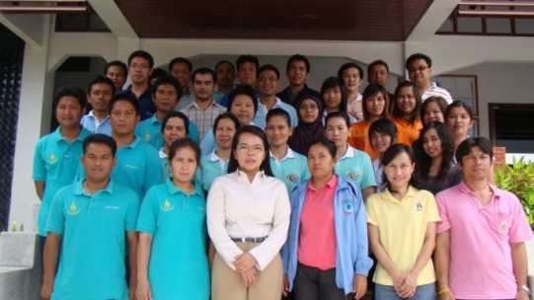 | 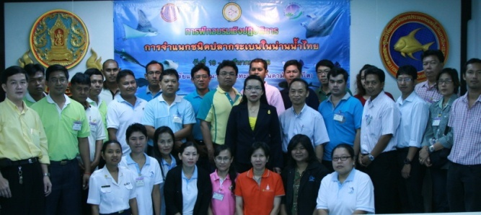
Photo 1. Participants and resource persons in 2011 and 2013
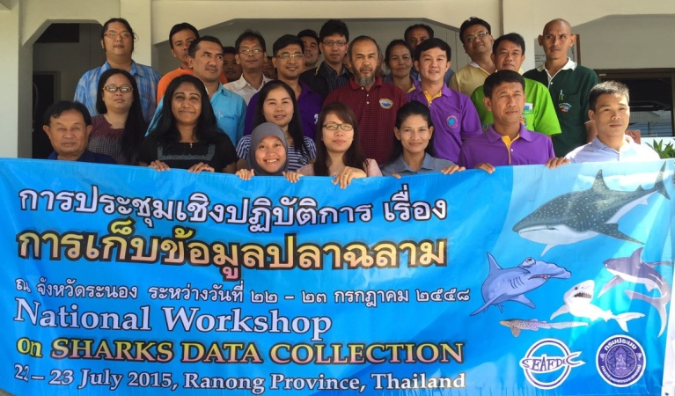
Photo 2. Participants and resource persons in 2015
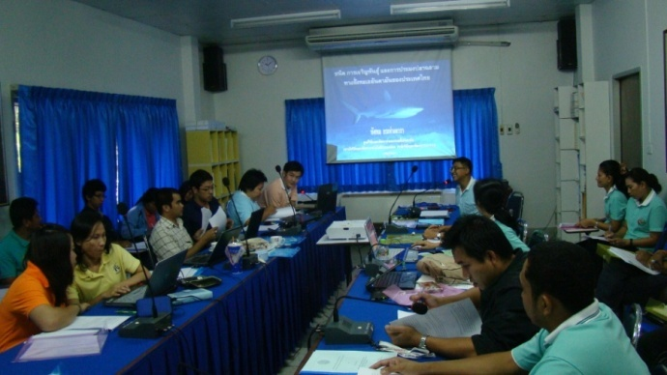 | 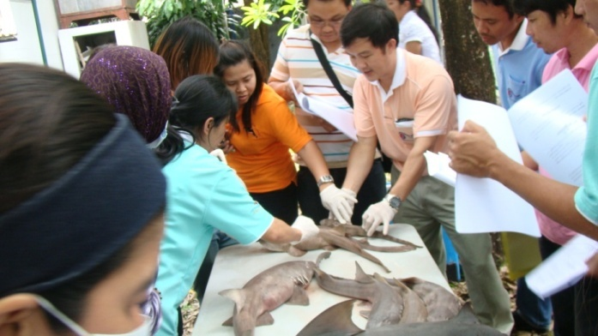
Photo 3. Participants during lecture and practical session
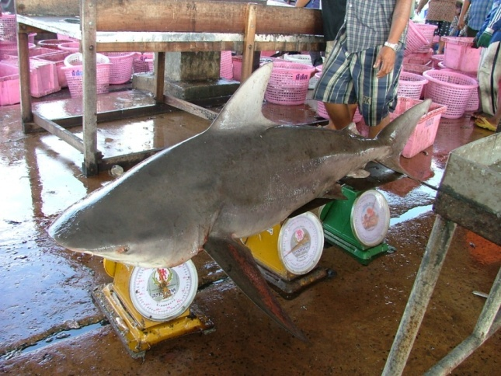 | 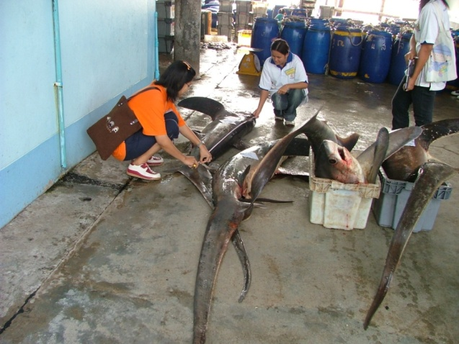
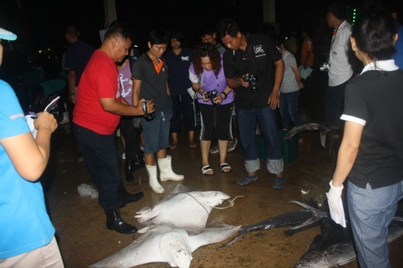 | 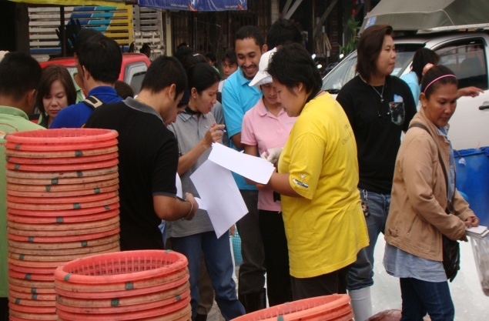
Photo 4. Enumerators worked at fishing ports
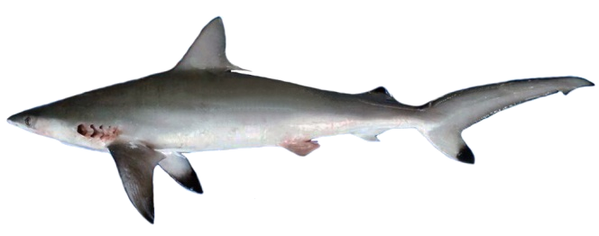  Carcharhinus sorrah | 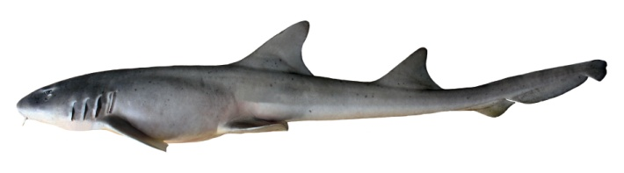  Chiloscyllium punctatum
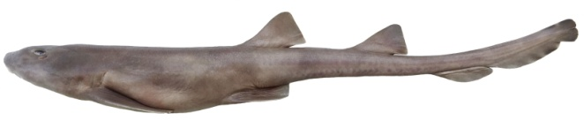  Chiloscyllium hasseltii | 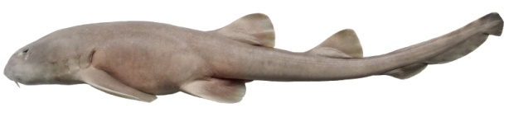  Chiloscyllium griseum

Photo 5. Common sharks in Thailand

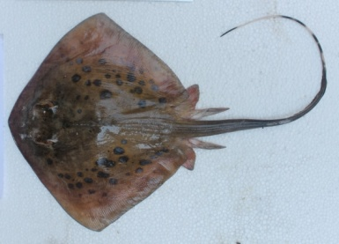  Neotrygon kuhlii | 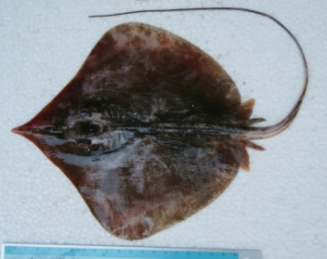  Dasyatis zugei | 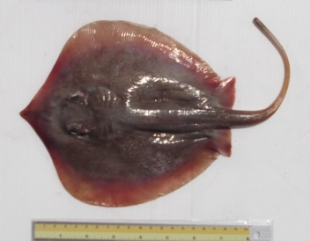  Himantura walga

Photo 5. Common rays in Thailand
Appendix V
Range size of small, medium and big by species (in cm). Disc width for all rays (except for species in family Rhinobatidae, Rhynchobatidae and Rhinidae) and Total Length for all shark species
Species | Small | Medium | Big
Rays
Aetobatus ocellatus | 30-60 | >60
Dasyatis akajei | 10-60
Dasyatis thetidis
Dasyatis zugei | 10-30
Gymnura japonica | 20-50
Himantura gerrardi | 20-50 | >50
Himantura imbricata | 10-20
Himantura jenkinsii | 20-50 | 51-100 | >100
Himantura uarnacoides | 20-50 | 51-100 | >100
Himantura walga | 10-20
Neotrygon kuhlii | 10-30
Plesiobatis daviesi
Rhinobatus formosensis | 20-40 | 41-100
Rhynchobatus australiae | 20-50 | 51-120 | >120
Taeniurops meyeni
Sharks
Atelomycterus marmoratus | 45-70
Carcharhinus amblyrhynchos | 80-120 | 121-200 | >200
Carcharhinus leucas | 80-120 | 121-200 | >200
Carcharhinus melanopterus | 80-120 | 121-200
Carcharhinus sorrah | 80-120 | 121-160
Chiloscyllium griseum | 45-90
Chiloscyllium hasseltii | 45-70
Chiloscyllium plagiosum | 45-90
Chiloscyllium punctatum | 45-120
Galeocerdo cuvier | 80-120 | 121-200 | >200
Hemigaleus microstoma | 70-100
Heptranchias perlo | 80-120
Sphyrna lewini | 80-120 | 121-200 | >200

